

**DEPARTMENT OF ELECTRONICS AND COMMUNICATION ENGINEERING**

**Academic Year: 2023-24**

Microwave and Radiating Systems

21EC72

UG Laboratory Companion Book

(Autonomous scheme 2021)

**EXPERIMENT 6**

**Design Simulation of Micro Strip Line and Hybrid Ring Using HFSS**

1. **Design of 50 Ω Microstrip line using HFSS**

Detailed HFSS Steps

In ANSYS Electronics Desktop

1. Insert HFSS Design
2. Project--> Insert HFSS Design
3. Creating ground plane for microstrip line
4. Draw--> Rectangle--> Mouse Pointer in the origin (0,0,0) (Ref Screenshot)

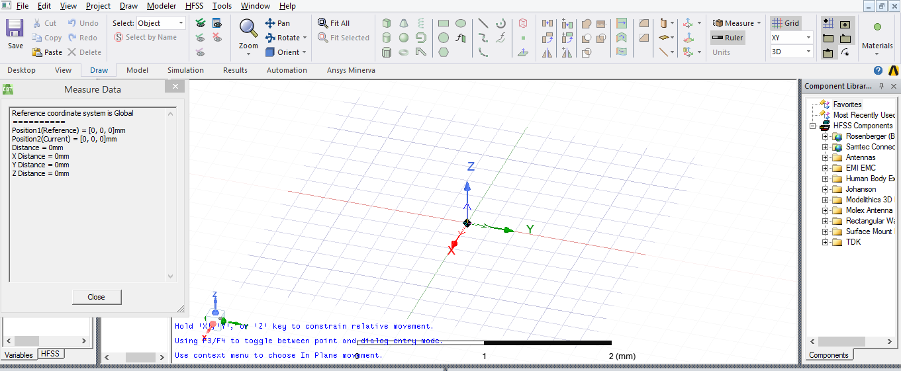

Draw rectangle with arbitrary X & Y Distances,

Rename the ground plane with name “ground”

Go to Model windows--> Rectangle1-->Attribute-->Name--> “ground”

Color--> Orange --> Enter OK

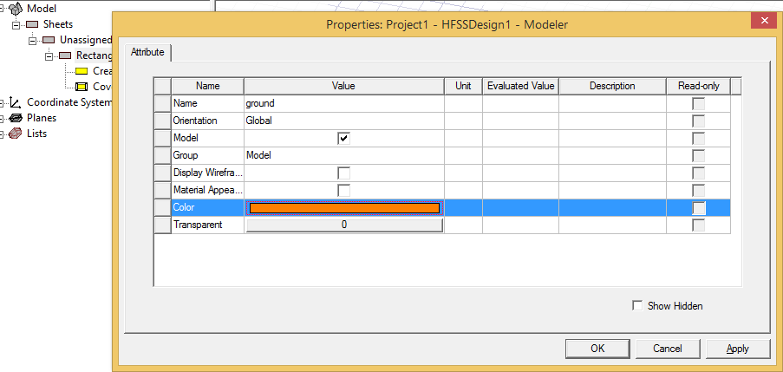

Select the ground plane dimension

Model--> ground--> CreateRectangle-->XSize--> 20mm, YSize-->40mm --> Enter OK

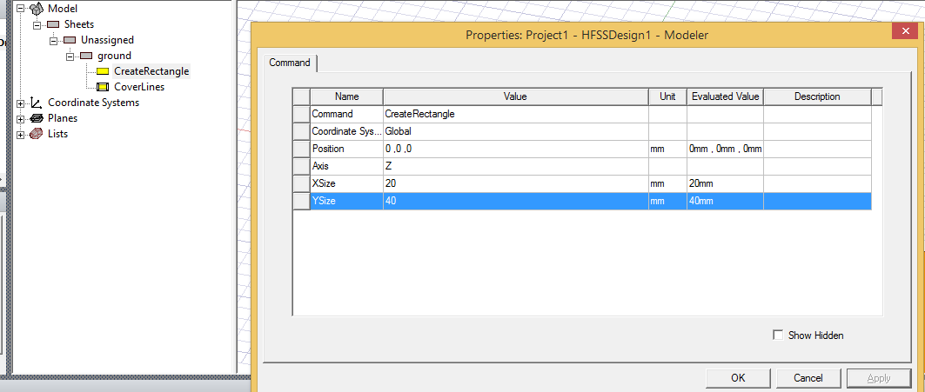Note: To Fit all models in window, View--> Fit all (or Ctrl + D)

Design substrate box

Draw--> Box-->Position--> Using mouse-->Origin(0,0,0)-->XSize-->20mm, YSize-->40mm --> Enter OK

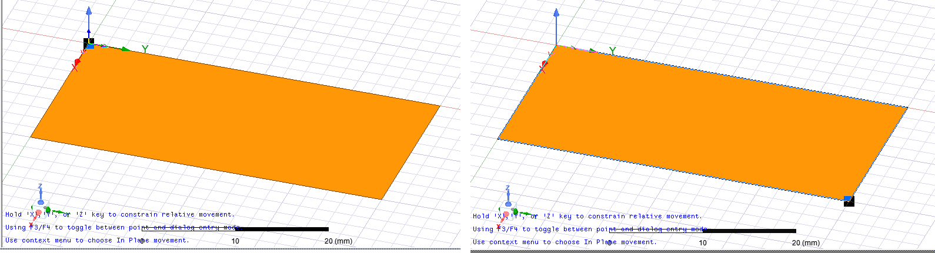

Rename the box with substrate & choose the substrate material

Solids-->vaccum-->Name-->” substrate” --> Material--> Edit..-->Search by Name--> “fr4” -->Select--> “FR4_epoxy” --> Enter OK

Change the thickness of the substrate

Model--> Solids--> FR4_epoxy-->substrate-->CreateBox-->ZSize-->1.6-->Enter OK

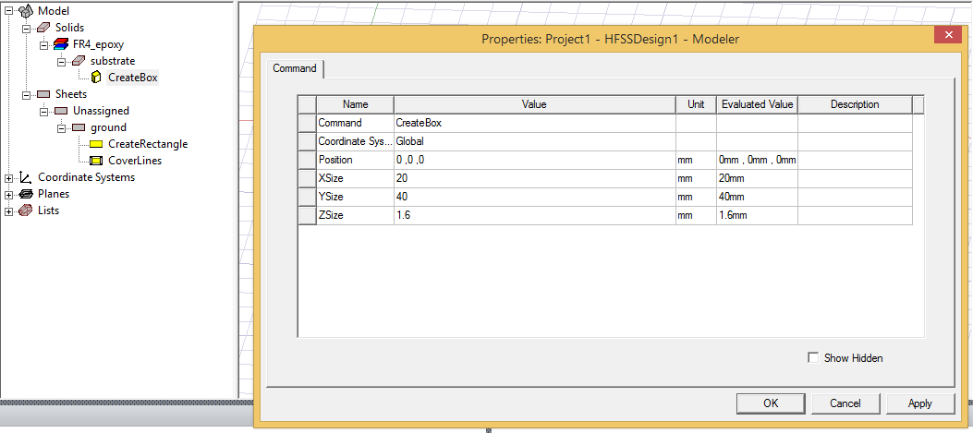

Design microstrip line at the top of the substrate

Draw Rectangle-->Using mouse pointer above substrate & change its attributes,

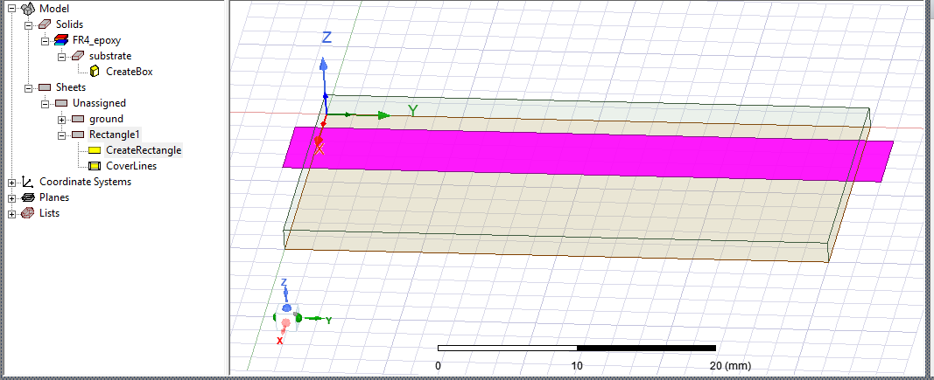

Sheets-->Unassigned-->Rectangle1-->Double click

Name--> “line”, Color--> Orange --> Enter OK

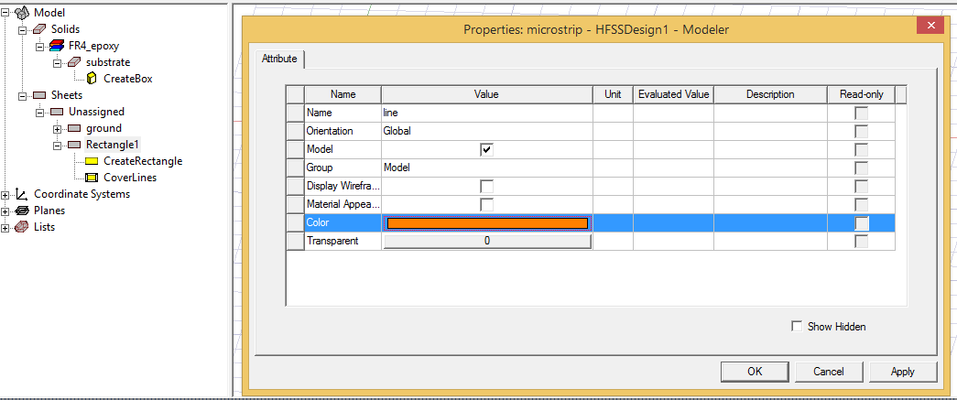

Change the dimension & position of micro strip line

Sheets-->line-->CreateRectangle

The microstrip line is positioned at top & center of the susbstrate.

Position--> 10-1.5, 0, 1.6

XSize-->3 (width of strip line)

YSize--> 40 (length of strip line)

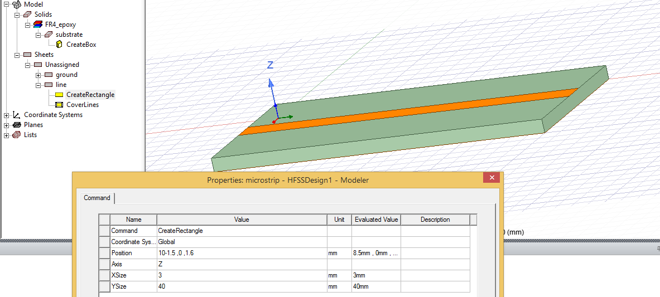

Assign field boundary to ground plane & micro strip line

Using Ctrl Command select both ground & line--> Right mouse click--> Assign Boundary--> Perfect E, Name-->PerfE1-->Enter OK

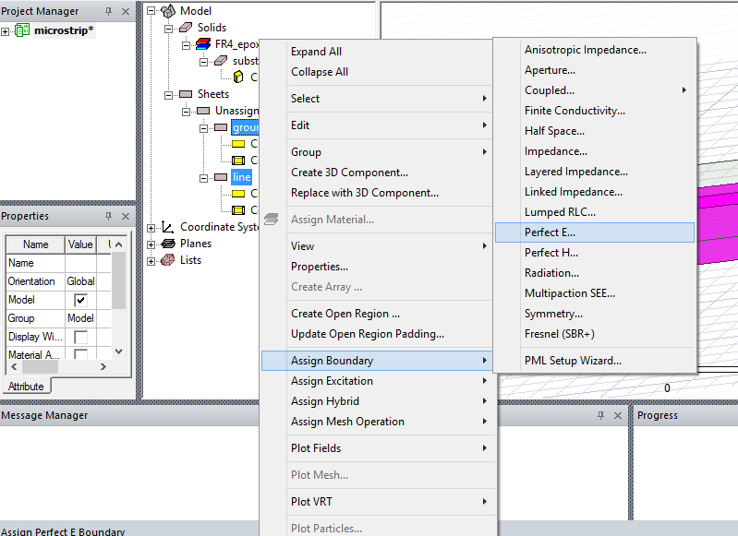

Assign excitation for port 1(input) & port 2(output)

In Draw panel, select X-Z plane

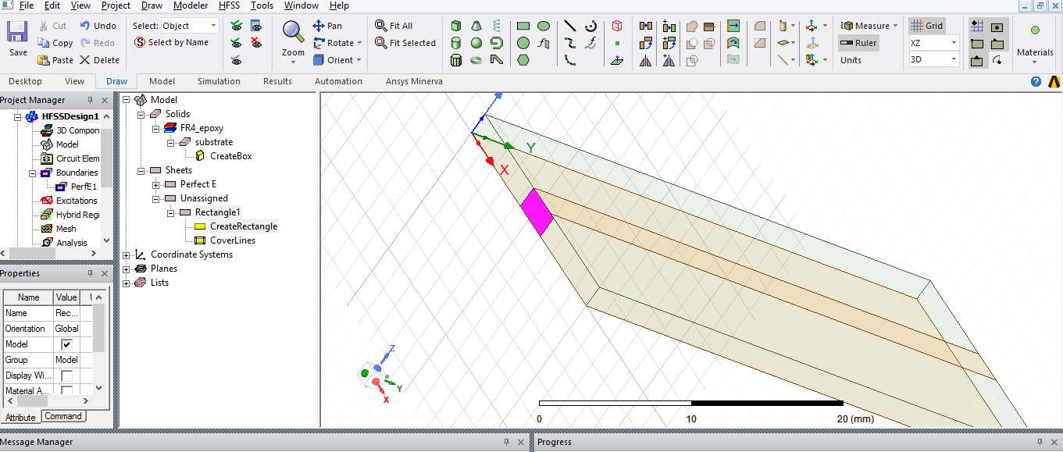

Draw--> Rectangle-->With mouse pointer select face of microstrip line

Change the attributes Model-->Sheets-->Unassigned--> Rectangle1-->Name--> “port1”-->Enter OK

Adjust the port1 dimension to accurate

Model-->Sheets-->Unassigned--> port1-->CreateRectangle

Position-->8.5,0,1.6

XSize-->3 (width of the strip)

Enter OK

Assign Excitation to port 1

Model-->Sheets-->port1--> Right Click on Mouse, Assign Excitation--> Lumped port-->Name-->1, Next-->Integration Line-->New Line--> Select on face of port 1 from up to down as shown below,

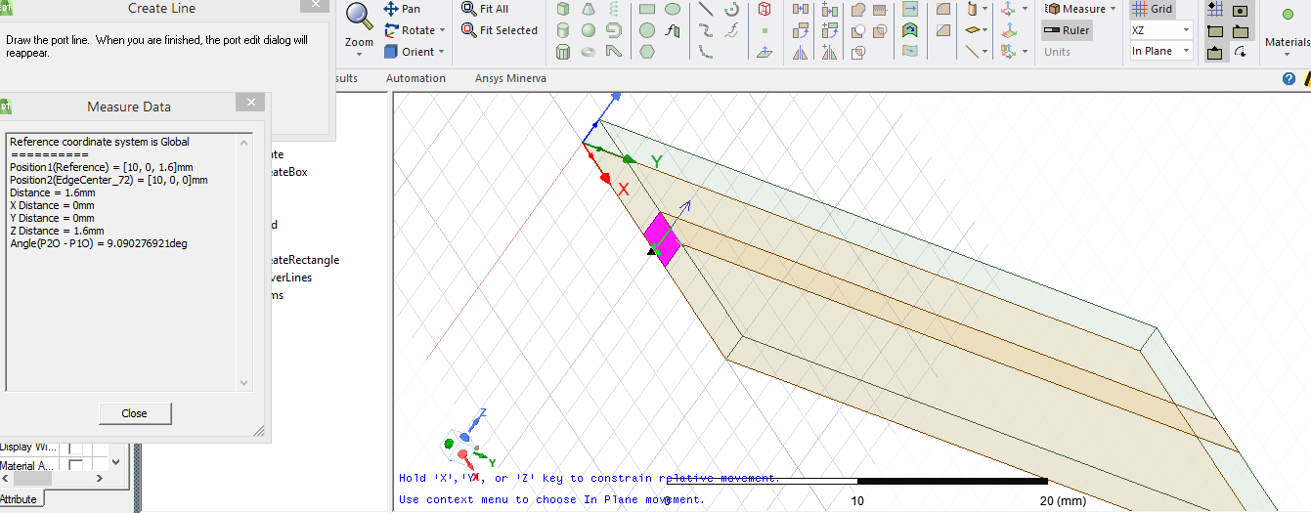

Next--> Enter Finish

Similarly assign port2

In View panel-->Rotate around current axis

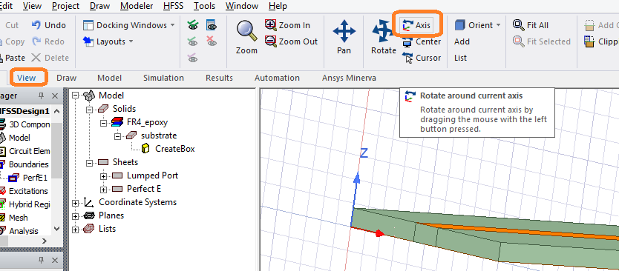

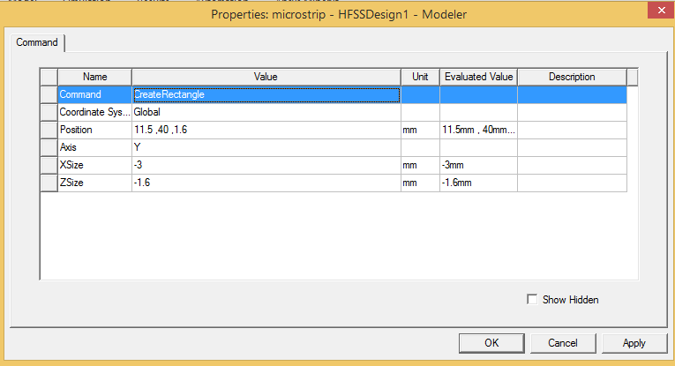

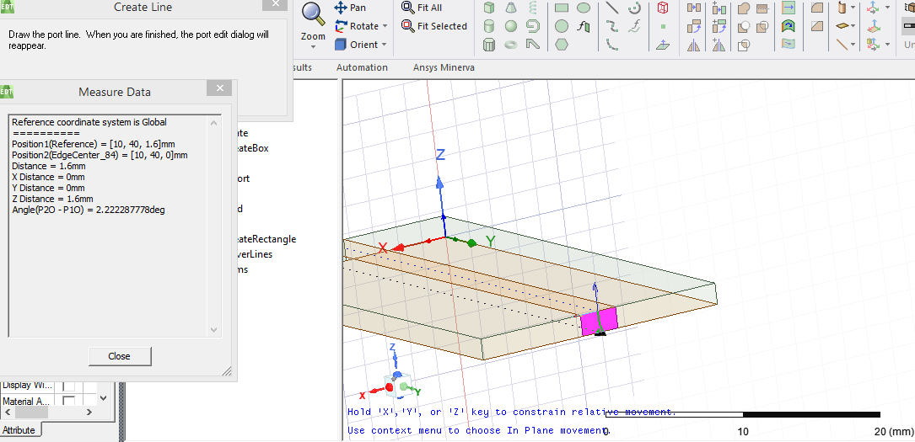

Verify the excitation in the Project manager explorer

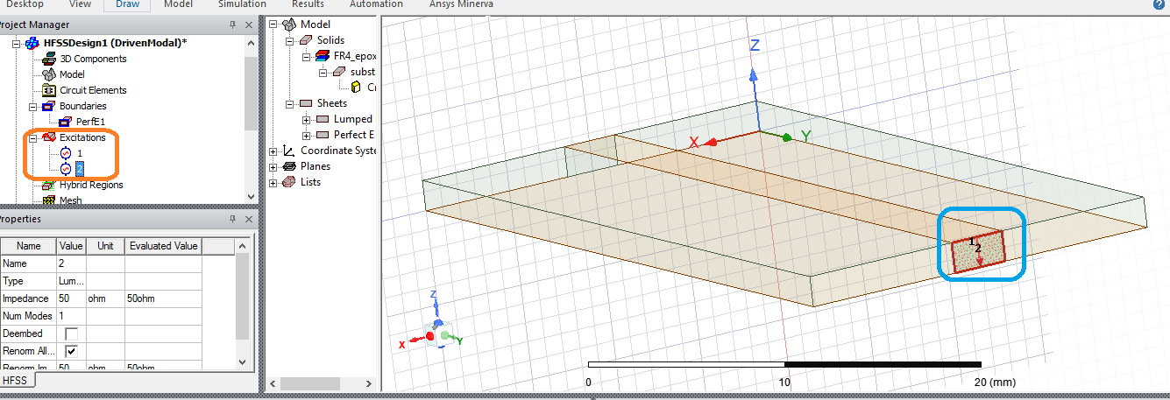

Create Radiation Box bigger than design structure

Draw-->Box

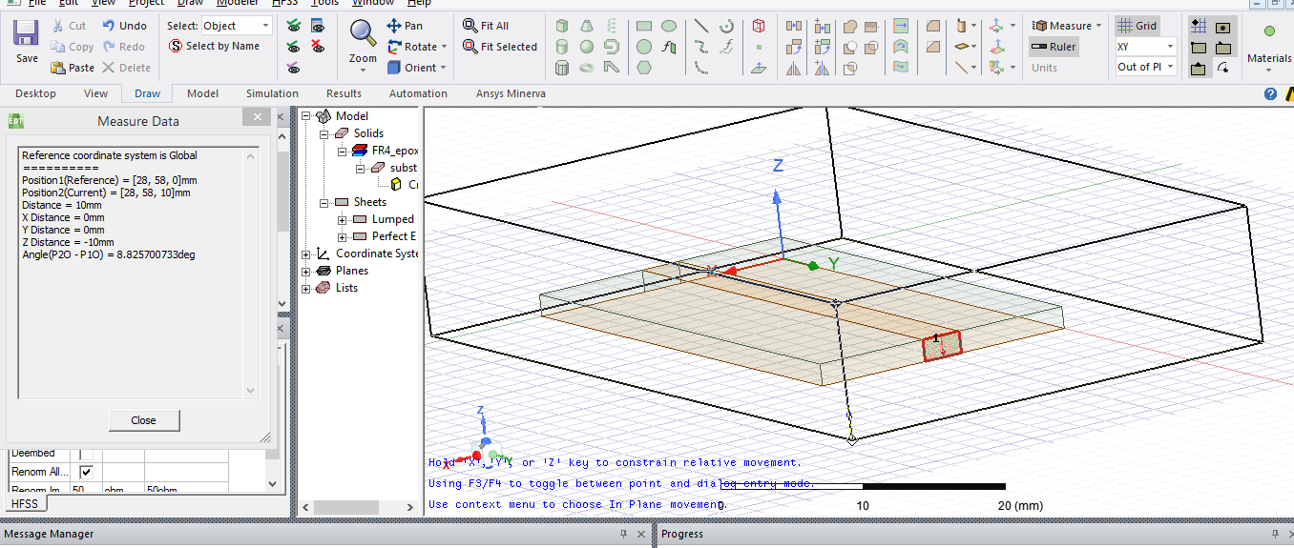

Change the attribute of the Box

Model-->Solid-->vacuum-->Box1-->Name--> “radiation”, material--> Search by name-->air-->Enter OK

Transparency--> 1 (To make design structure inside box visible)-->Enter OK

Fine tune the Radiation box position & dimensions

Model--> Solids-->air-->radiation-->CreateBox

Position: -10, -10, -20

XSize: 40

YSize: 60

ZSize: 40

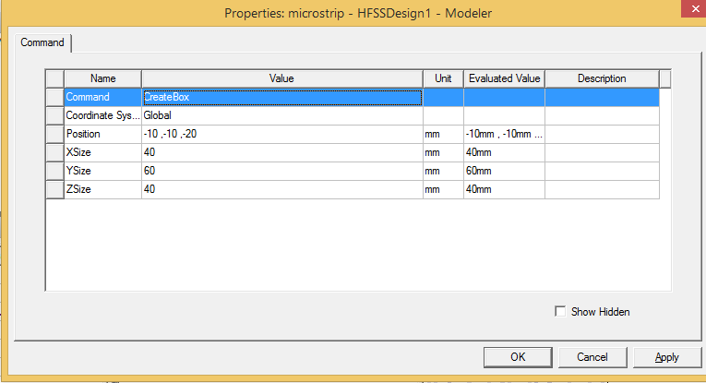

To fit all structure

Ctrl +D or View-->Fit all

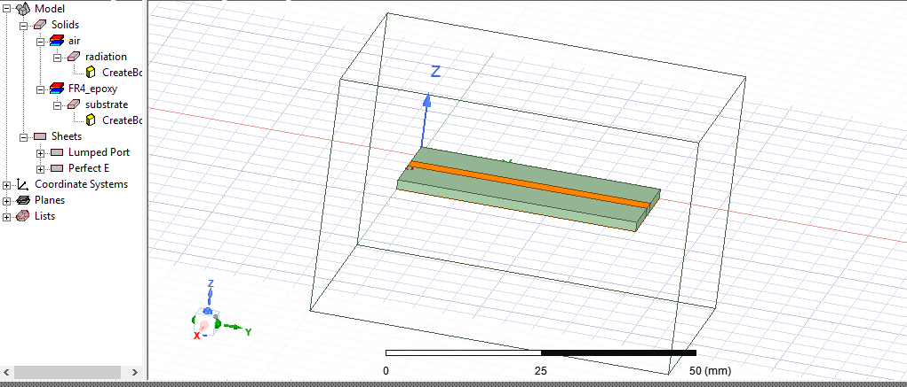

Assign radiation boundary to box

Model--> Solids-->air-->radiation, Right click on Mouse--> Assign Boundary--> Radiation--> Enter OK

Now micro strip line structure is designed and boundary & excitation are defined.

To analyze the results,

In project manager explorer

HFSS Design-->Analysis--> Right Click--> Add Solution Setup--> Advanced-->Solution Frequency 5 GHz--> Enter OK

Under Edit Sweep frequency

Distribution--> Linear Step--> 1 GHz (Start) 20 GHz (End), Step Size--> 0.1 GHz, Sweep Type--> FastClick on “Preview” to check the number of iterations execution

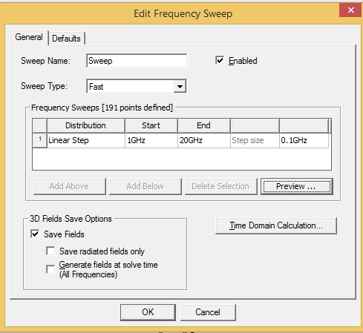

(Note: User can also use “interpolation” sweep type)

Enter OK

**Note: Continue the remaining steps in the lab manual for the results**

1. **The hybrid ring design using microstrip line in HFSS**

Draw Circle,

Change the attributes & position of circle as below,

Centre position: 0, 0, 0 mm

Radius= 17.52 mm (Outer Circle) 🡪 Enter OK

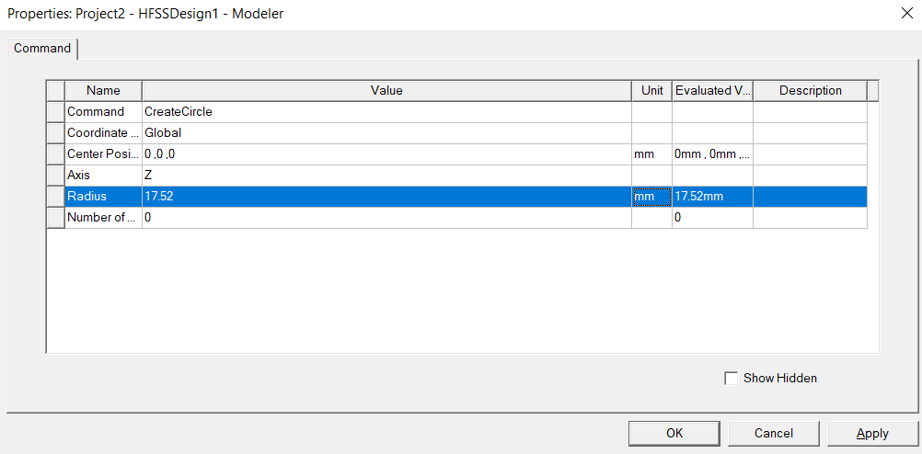

Fit View🡪 Ctrl+D or View🡪 Fit all

Duplicate the same circle

Under Model🡪 Sheets🡪Unassigned, Right Click on Mouse Circle1, Edit🡪 Copy and Paste in the Same directory

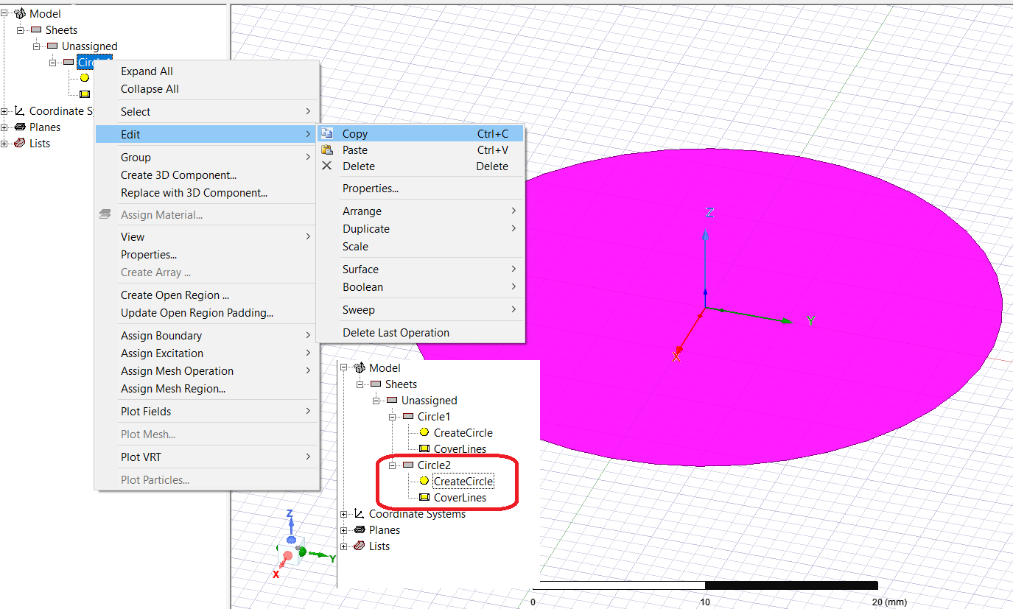

Change the radius of Circle2 as 15.9 mm as mentioned step above.

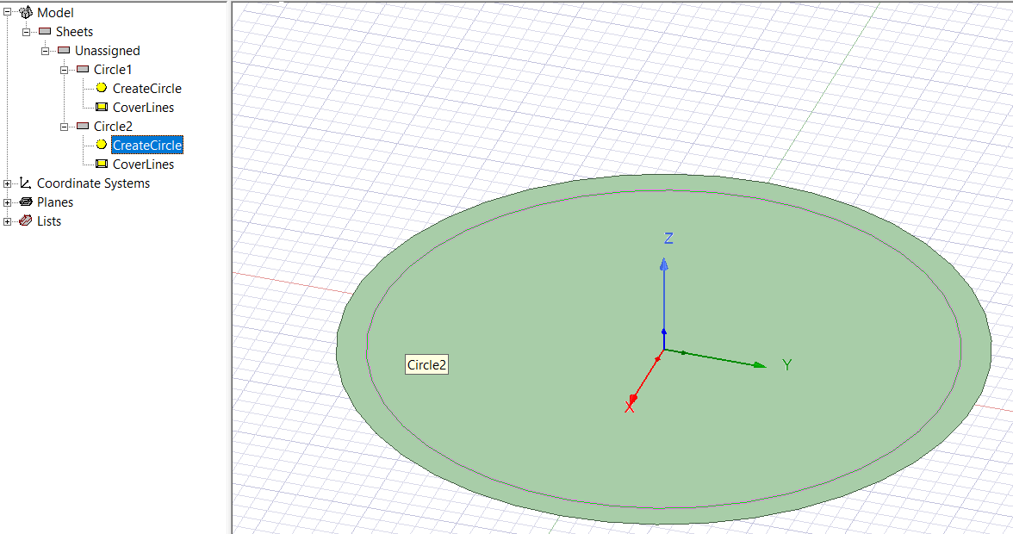

Circle 1

Circle 2

Subtract Circle1-Circle2

Using Mouse pointer, Select Circle1 and Circle 2

Modeler🡪 Boolean🡪 Substrate or in Draw panel🡪 Subtract

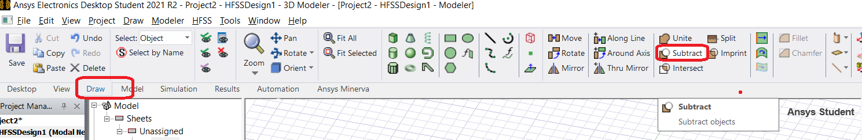

In Subtract pane🡪 Enter OK

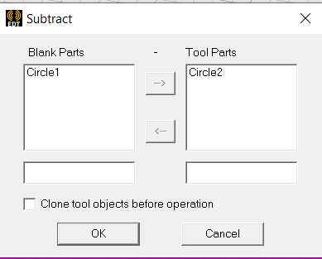

Drawing the first port

Change the TOP view orientation by

View🡪 Modify attribute🡪 Orientation🡪 Orientation List🡪 top🡪 Apply to View🡪 Close

**Draw rectangle with the port line width**

Draw🡪 Rectangle

Model🡪 Sheet🡪 Rectangle1🡪CreateRectangle

Position: -1.5, -40, 0 (since width is measure along X-axis along origin, the X range is (-1.5 to 1.5 mm, total 3mm and Y-axis position -40 + YSize of 24 =-16 position which overlap on ring)

XSize🡪 3 mm

YSize🡪24 mm

Enter OK

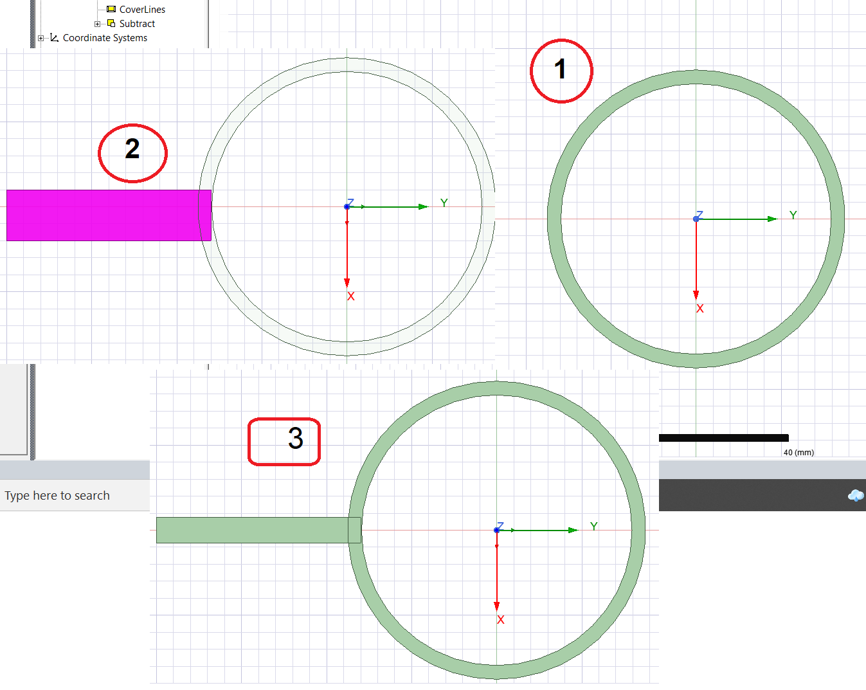

Note: The port line length can be shortened by changing the position & size of rectangle. For e.g,

In Model🡪 Sheet🡪 Rectangle1🡪CreateRectangle

Position: -1.5, -30, 0

XSize: 3

YSize: 14

Draw other ports

From the design, duplicate and create other ports

Rotate the port(B) along Z- axis of -90 deg



Rotate the port (B) along Z- axis of +90 deg

-30 deg

+90 deg

-90 deg

Z (Coming outward from paper)

+30 deg

60 deg

**B**

Y

X

Select the port and in draw panel, Duplicate around Axis🡪 Axis🡪Z, Angle🡪-90 deg, Total number🡪2 (port 2)

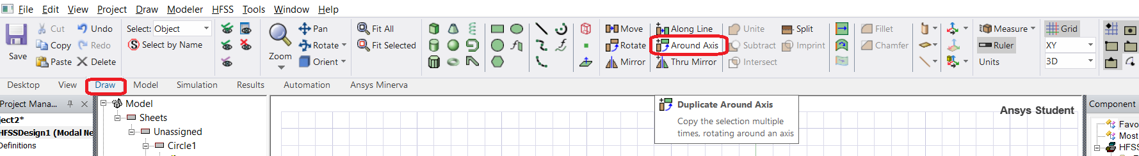

Similarly,

Select the port and in draw panel, Around Axis🡪 Axis🡪Z, Angle🡪90 deg, Total number🡪2 (port 4)

Select the port and in draw panel, Around Axis🡪 Axis🡪Z, Angle🡪-30 deg, Total number🡪2 (port 1)

Move the remaining port to +30o degree

Select the port and in draw panel, Rotate🡪 Axis🡪Z, Angle🡪30 deg (port 2)

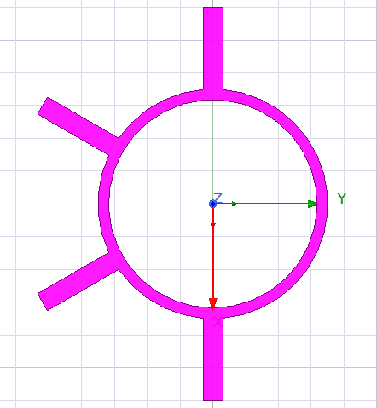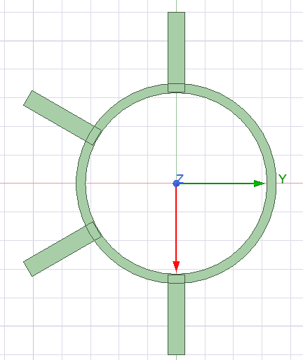

Select ALL objects and unite

In Draw panel🡪 Unite (or) Modeler🡪 Boolean🡪 Unite

Change the properties of ALL objects as “ring” by changing it attribute Name as “ring”

**Draw the substrate & ground plane beneath hybrid ring**

Select ALL Object🡪Edit🡪 Select All,

In Draw panel, Rotate🡪Axis🡪Z, Angle🡪30 deg🡪 Enter OK

Creating ground plane:

Draw regular polyhedron

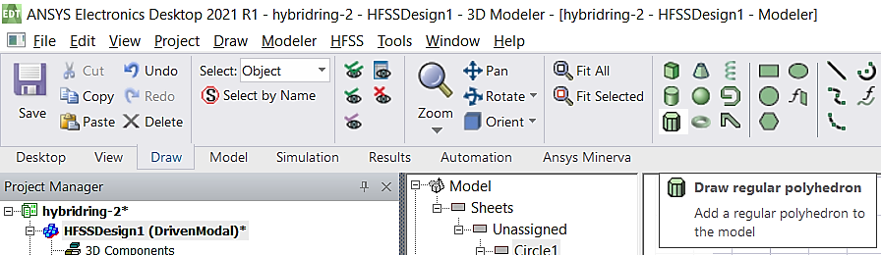

Use mouse pointer, select origin and draw the circle and choose Number of segments: 6

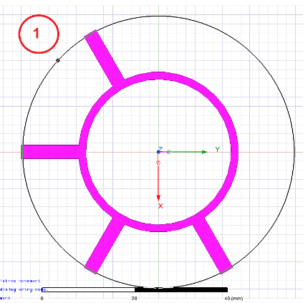

Choose the properties of polyhedron (ground plane),

Model🡪 Sheets🡪Unassigned🡪RegularPolyhedron1🡪 CreateRegularPolyhedron

Select properties as,

Centre position: 0, 0, 0

Start position: 30mm/cos(30*pi/180) ,0mm ,0mm (**Note:** radius of polygon is port line length/ cos(30*pi/180). Pythagoras theorem)

Axis: Z

Height: 0 mm

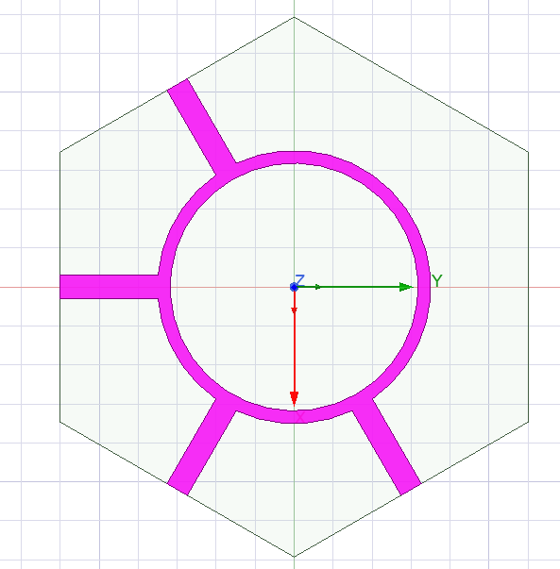

Duplicate polyhedron for substrate:

Select the ground plane, Model🡪 Sheets🡪Unassigned🡪RegularPolyhedron1, Right Mouse Click🡪 Edit🡪 Copy & Paste in same location (RegularPolyhedron2 will be created)

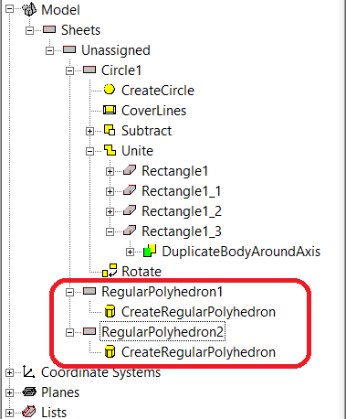

Choose the properties of polyhedron (substrate),

Model🡪 Sheets🡪Unassigned🡪RegularPolyhedron2🡪 CreateRegularPolyhedron

Select properties as,

Centre position: 0, 0, 0

Start position: 30mm/cos(30*pi/180) ,0mm ,0mm (**Note:** radius of polygon is port line length/ cos(30*pi/180). Pythagoras theorem)

Axis: Z

Height: -1.6 mm

Assign substrate material,

Solid🡪 Vacuum🡪 RegularPolyhedron2🡪 Material🡪 Edit🡪Search by Name🡪FR4_epoxy

Move the ground-plane polyhedron beneath substrate

Draw panel 🡪 Orient🡪 Trimetric

Select Face of RegularPolyhedron1,

In Draw panel, Select🡪Select by Name🡪 RegularPolyhedron1

Move in Z-Axis

Draw panel🡪 Move

Select the corner of RegularPolyhedron1 and move down in Z-axis by -1.6mm

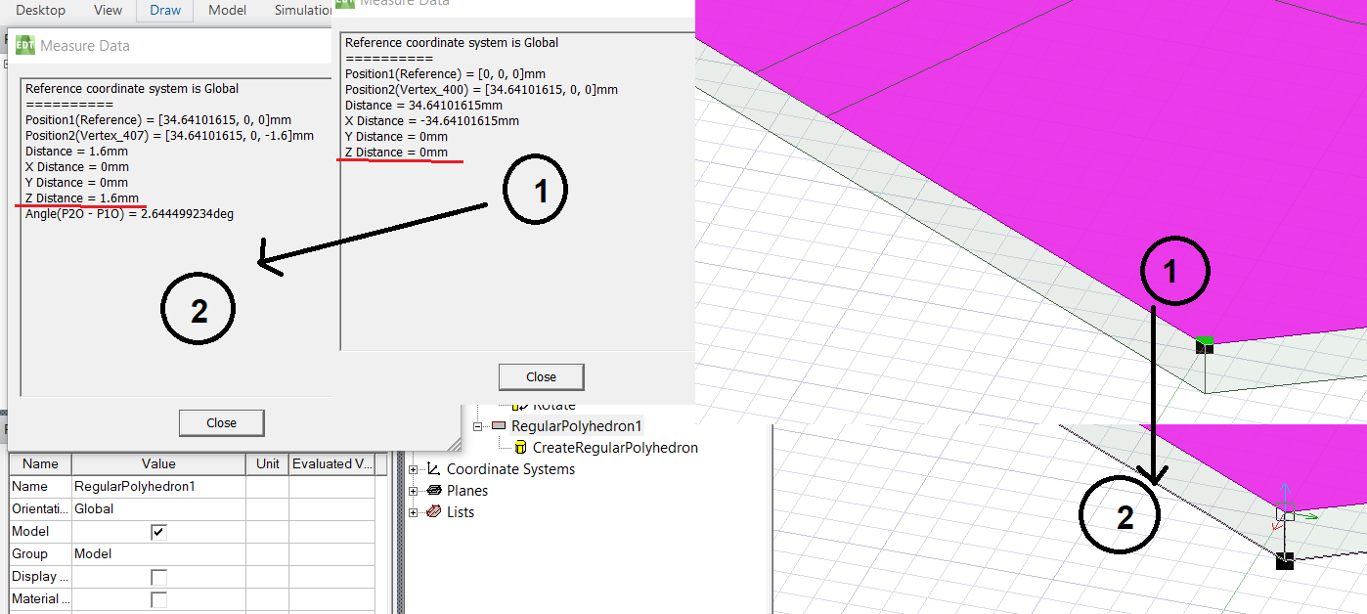

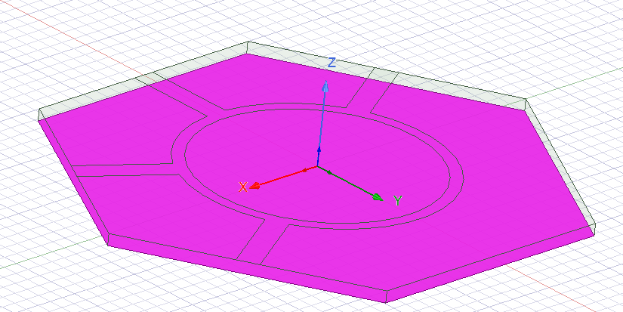

Place the rectangle sheet in all port as a lumped port

Note: Every time rotate 30/60o degree and draw rectangular sheet for each port

Select ALL Object, Edit🡪 Select All

Draw panel🡪 Rotate🡪 Axis: Z, Angle🡪 30 deg

Drawing rectangle on each port:

In Draw panel🡪

Change the drawing plane choose the plane accordingly (YZ)

Draw🡪 Rectangle on every port

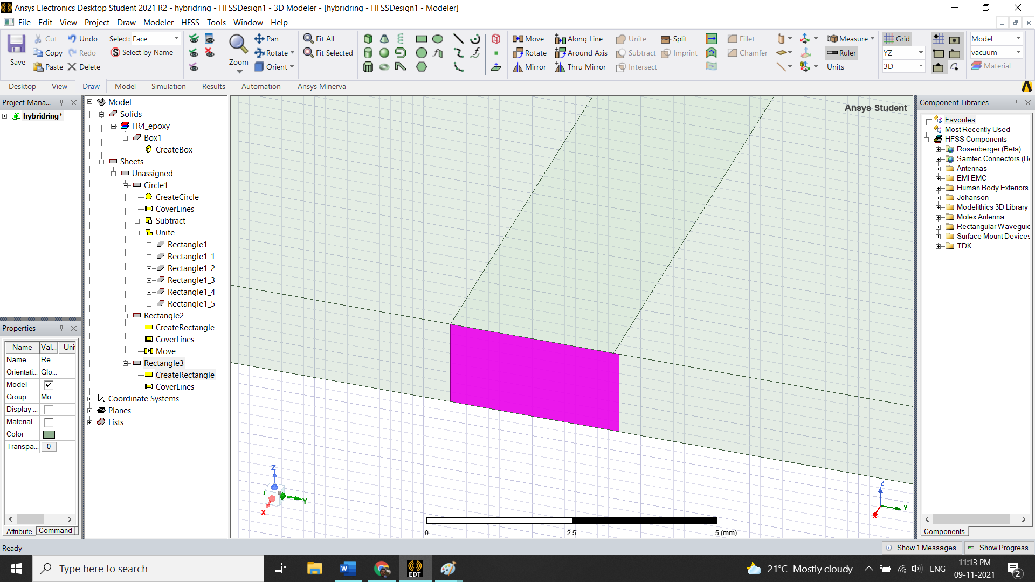

For e.g port 3 (Note: In view panel, Use Pan & Zoom in to draw)

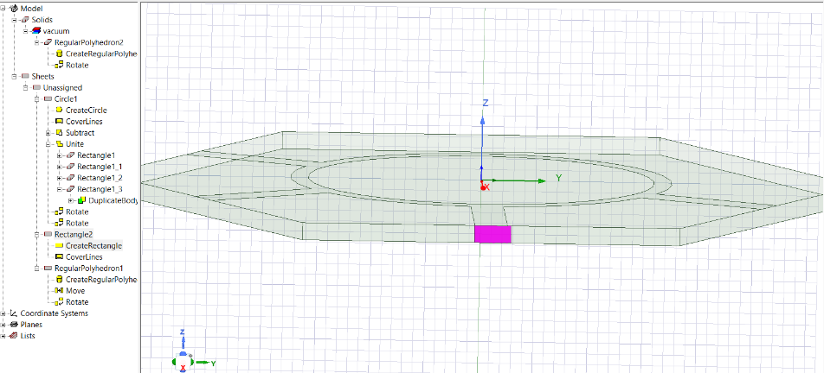

Adjust the dimension of rectangle to match with width of strip line.

(Rectangle2🡪 CreateRectangle🡪 YSize🡪3 mm

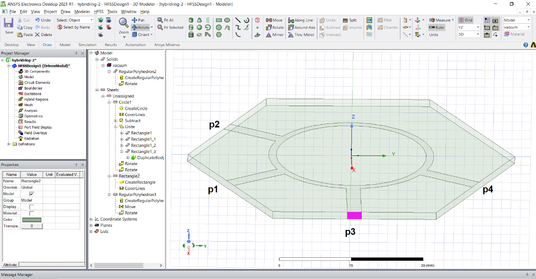

Before rotating the object,

Change the orientation: Draw🡪Orient->Top(-Z)

Select ALL Object, Edit🡪 Select All

Draw panel🡪 Rotate🡪 Axis: Z, Angle🡪 60 deg (for port 1 & 2) 180 deg (for port 4)

Draw🡪 Rectangle on every other port (Hint: Use view🡪 Fit all, Rotate around axis to choose other ports for drawing).

**Assign Port excitation**

1. Select the port face object individually🡪 Right mouse click🡪 Assign excitation🡪Port🡪 Lumped port🡪Name🡪1 or 2 or 3 or 4 (Provide the name according to hybrid ring design)🡪 Integration line🡪 New line🡪Select on face of port from bottom to up at middle(Ref microstrip line)

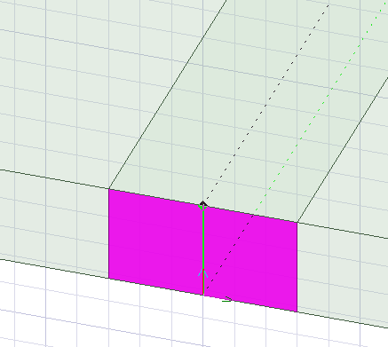

1. Assign excitation for remaining ports. (Note: While selecting integrating line on face of port object, keep relevant plane of reference either XY or YZ or XZ)
2. Excitation port can be verified in project manager under excitation numbered 1 to 4.

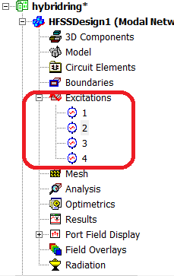

1. Assign Boundary to ring and ground plane
   1. Select the ring, Model🡪 Sheet🡪 Unassigned🡪ring than
   2. Right mouse click🡪 Assign the Boundary🡪 Perfect E🡪 Enter OK
   3. Select the ground plane, Sheets🡪 Unassigned🡪 RegularPolyhedron1 than
   4. Right mouse click🡪 Assign the Boundary🡪 Perfect E🡪 Enter OK
   5. Create Radiation bigger enough to accommodate hybrid ring
2. Draw Box, In Attribute🡪Position🡪 (-50, -50, -50)
   1. XSize:100
   2. YSize:100
   3. ZSize:100
3. Assign material as “Air” to Box, Solids🡪 vacuum🡪Box2🡪Right Mouse click🡪Assign material🡪 Search by Name🡪 air.
4. Increase the transparency of Box to view the device structure inside the box
   1. Solids🡪 air🡪Box2🡪Right Mouse click🡪properties🡪transparency🡪 0.7 to 1
5. Assign Boundary as Radiation to Air Box
   1. Solids🡪 air🡪Box2🡪Right Mouse click🡪Assign the Boundary🡪 Radiation🡪 Enter OK

**Note: Continue the remaining steps in the lab manual for the results**

**EXPERIMENT 7**

**Design and Simulation of Rectangular Waveguide and Magic-Tee using HFSS**

1. 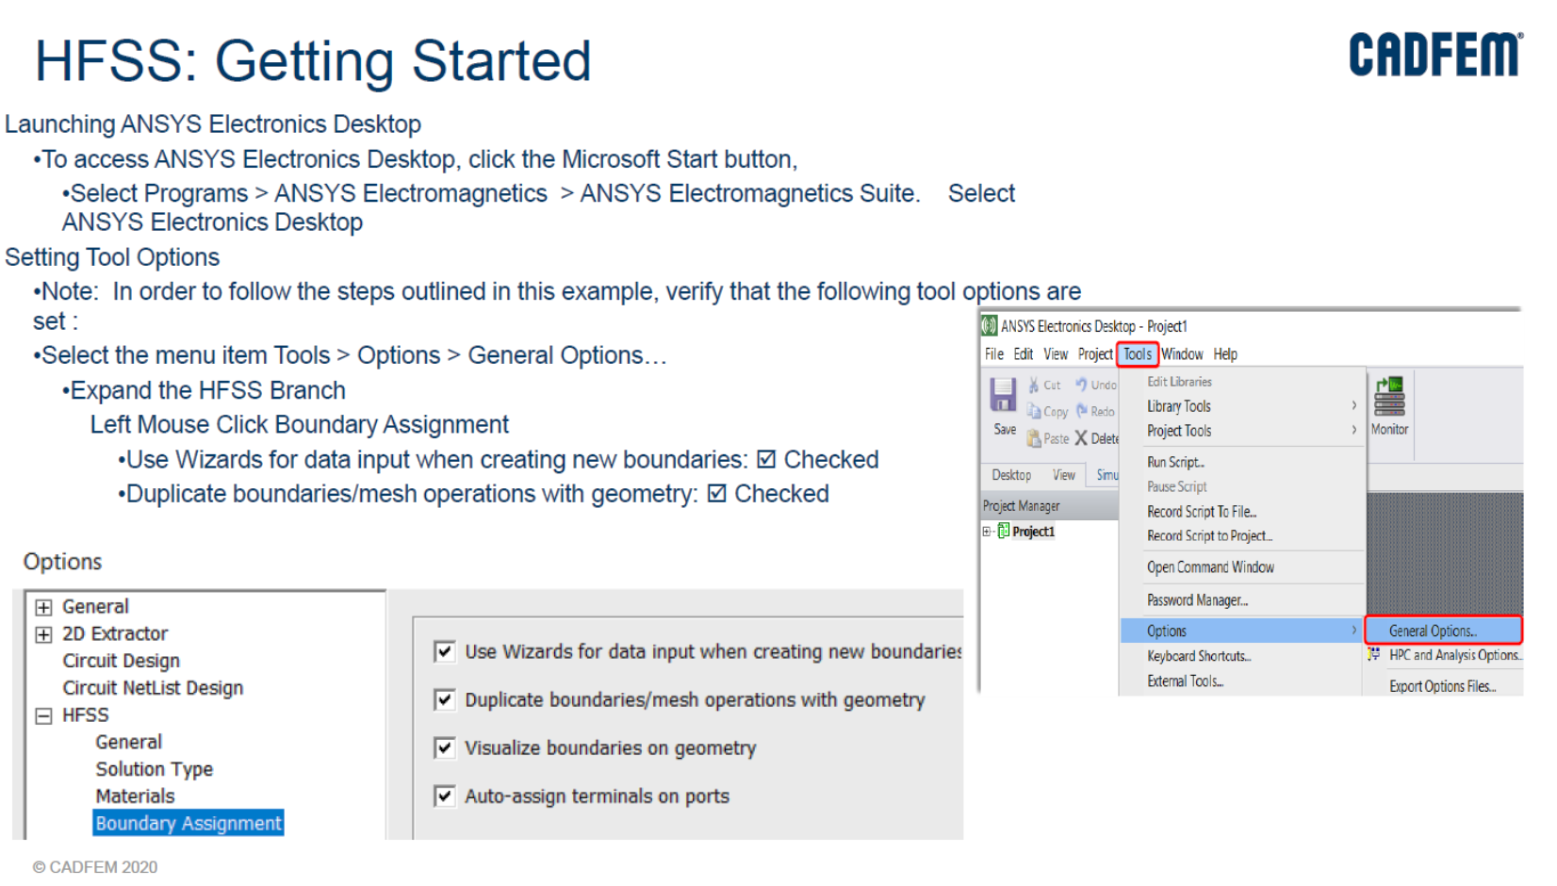 **Simulation of Rectangular Waveguide**

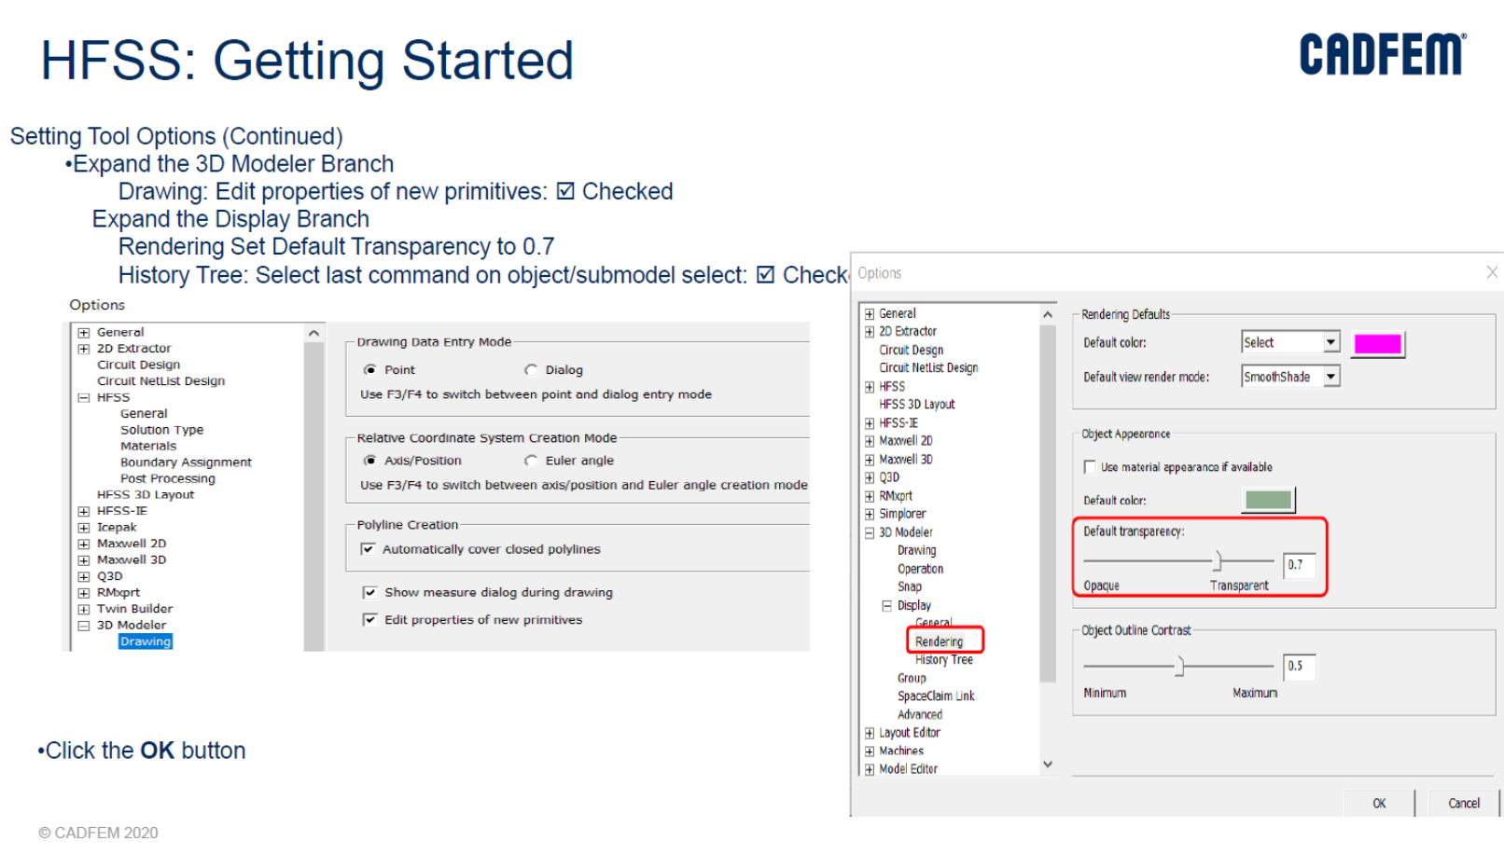

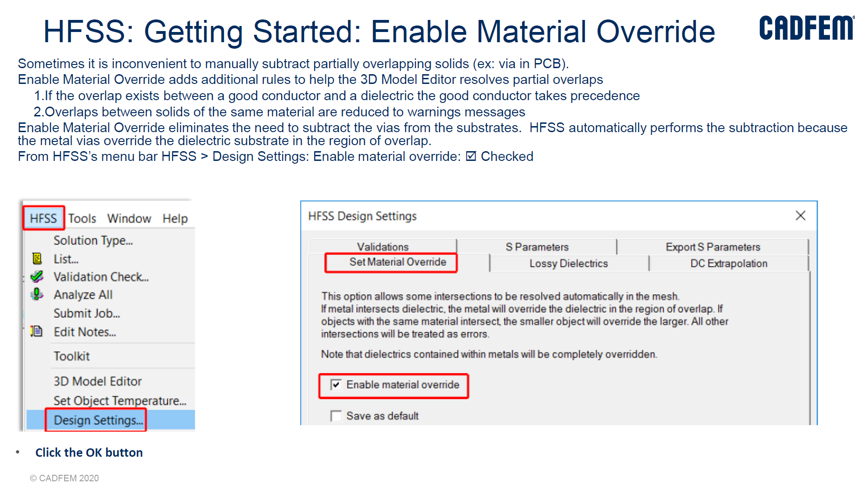

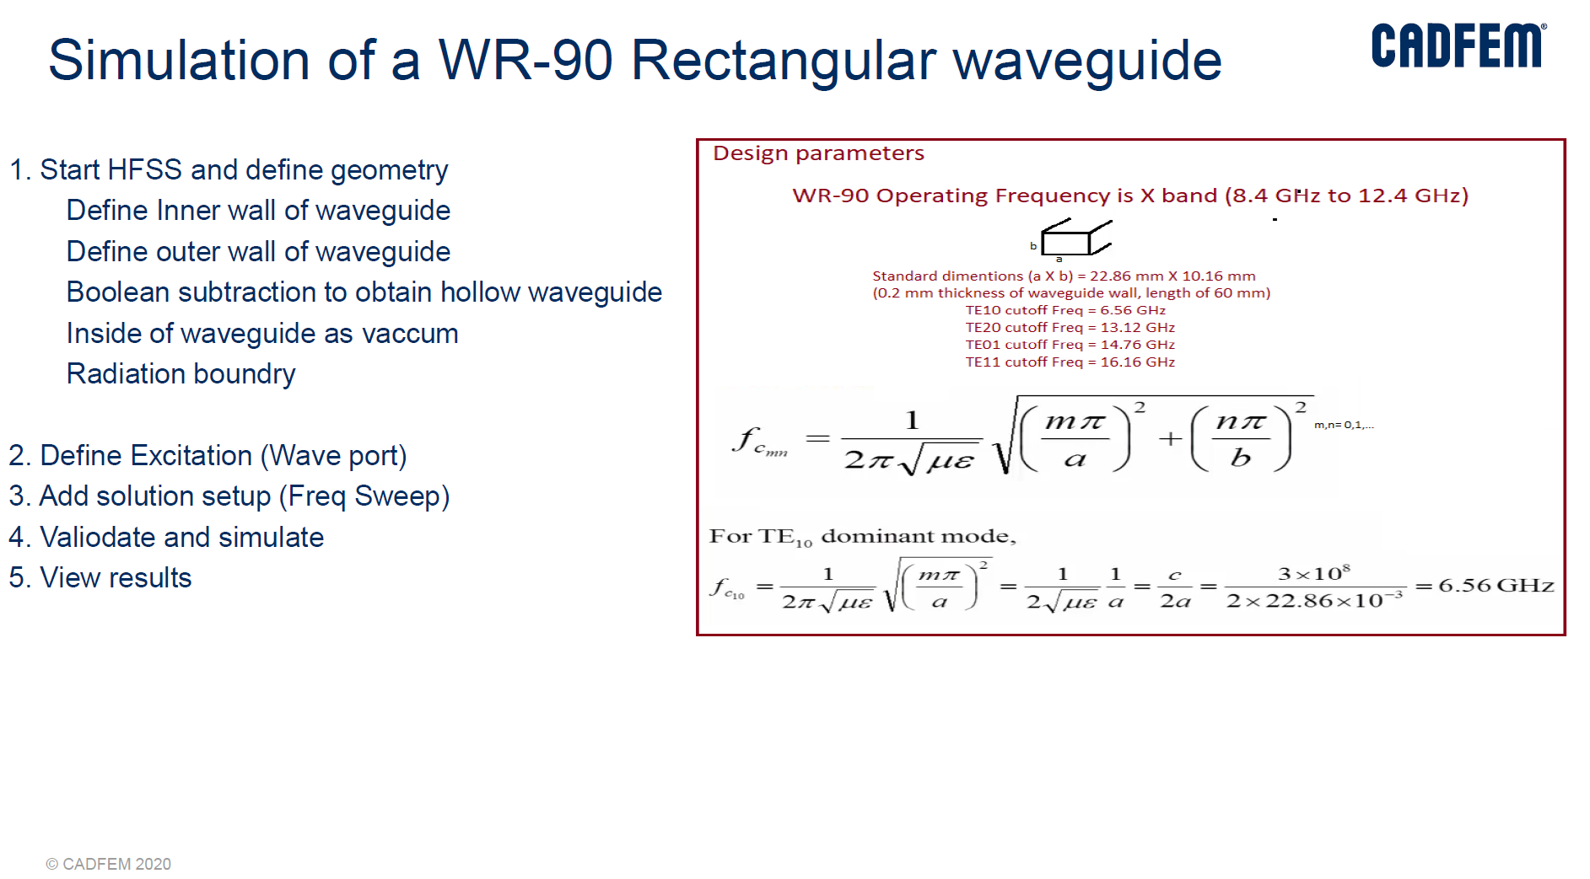

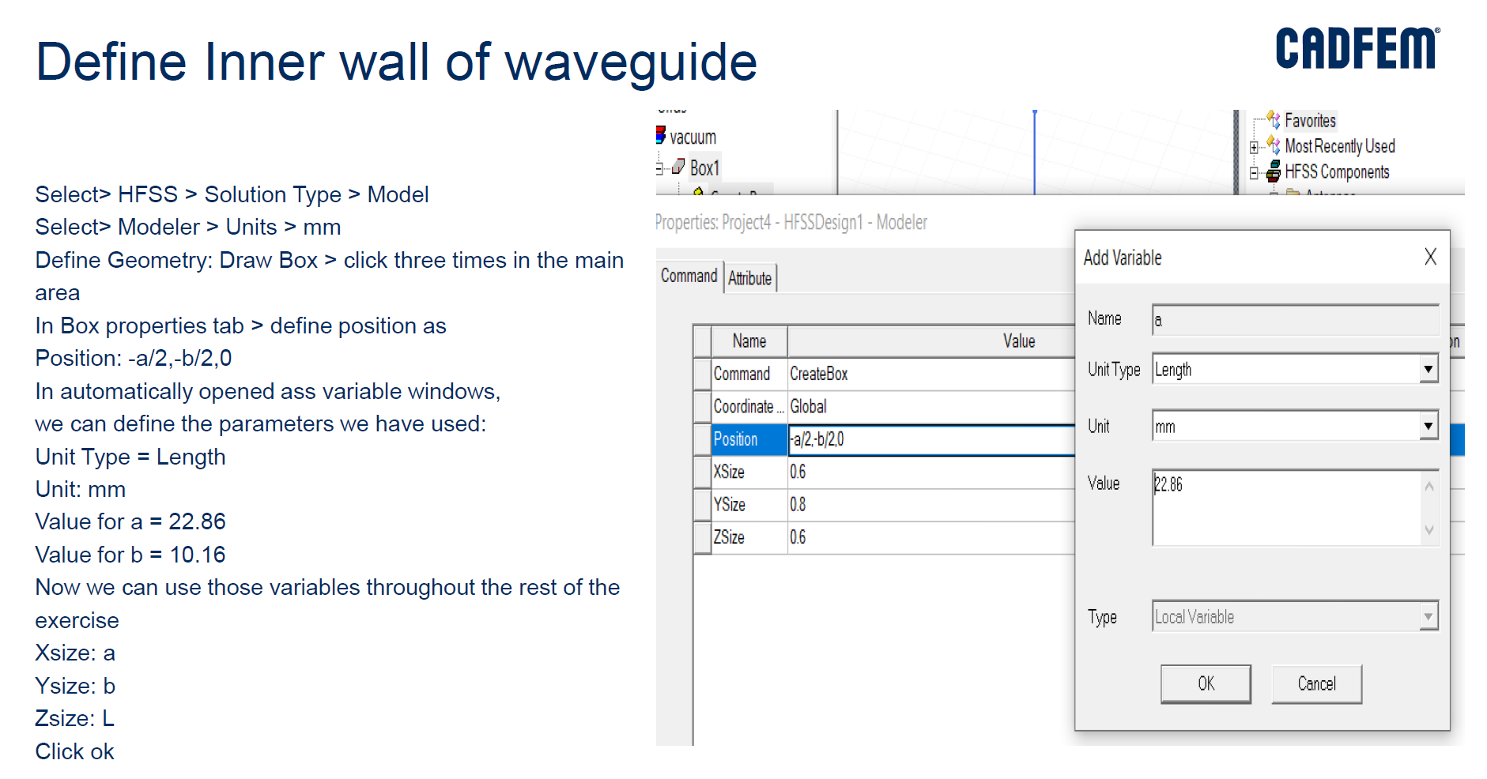

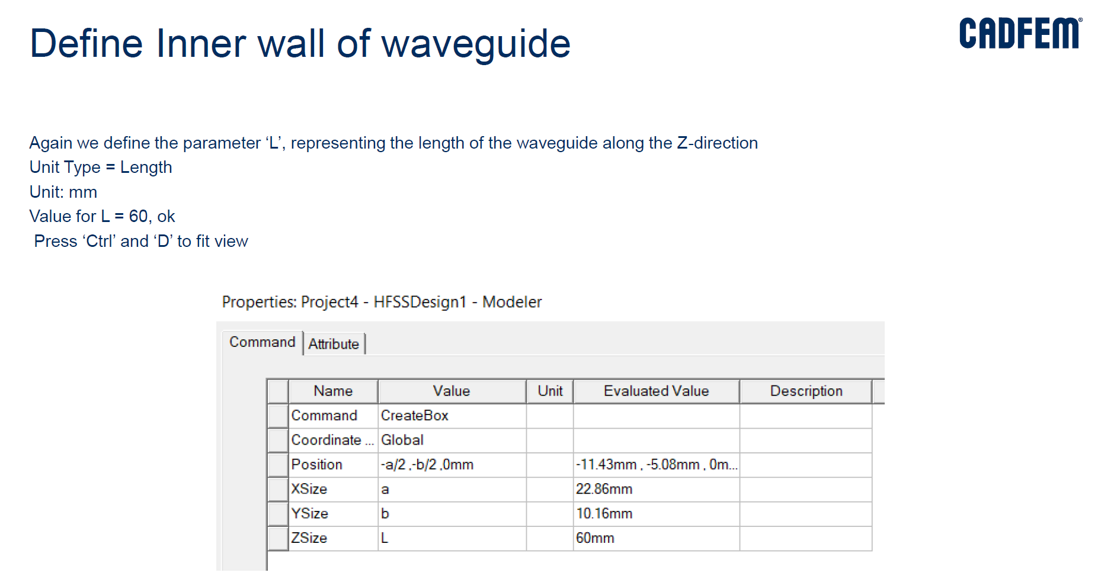

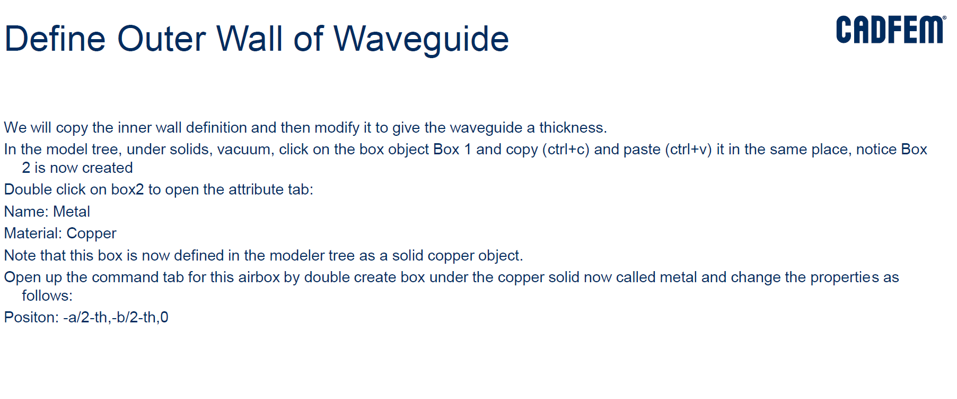

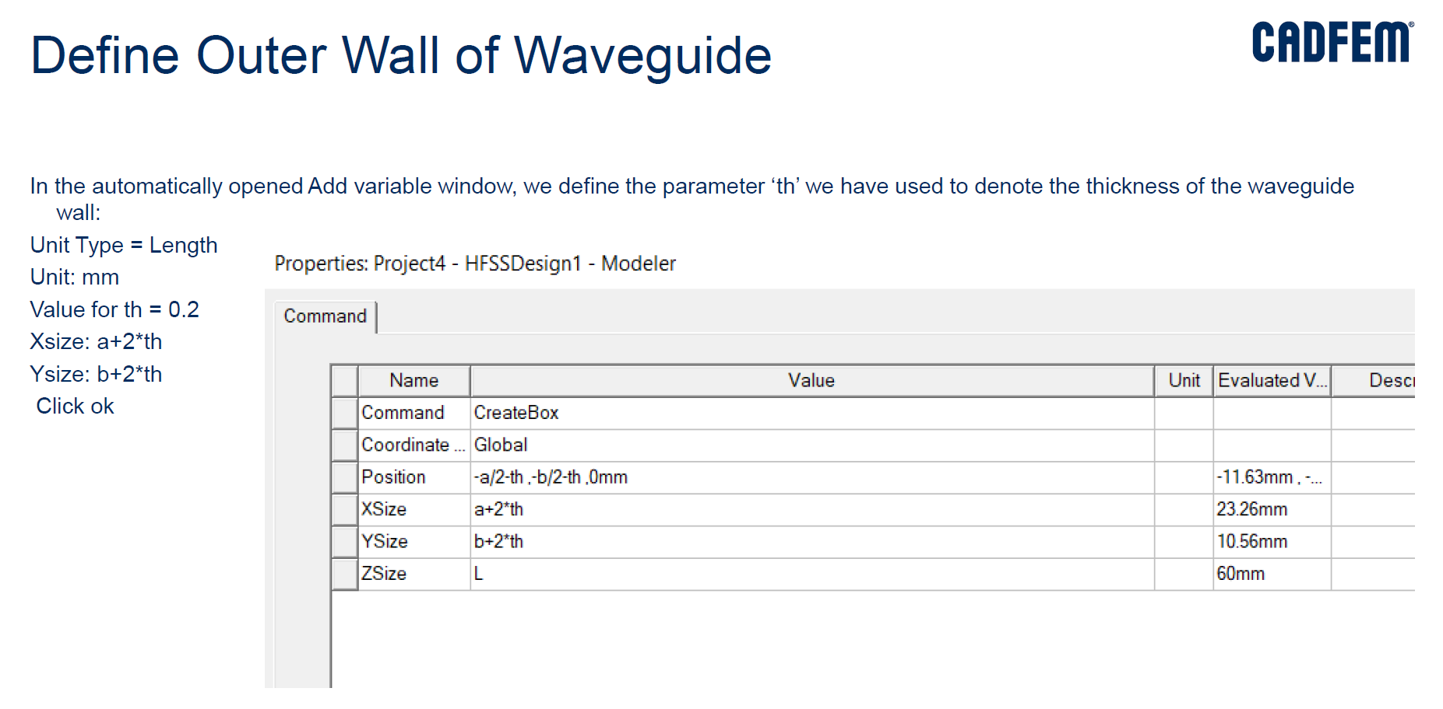

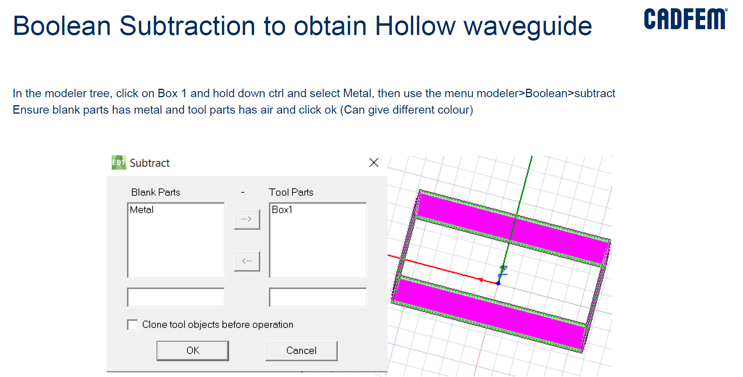

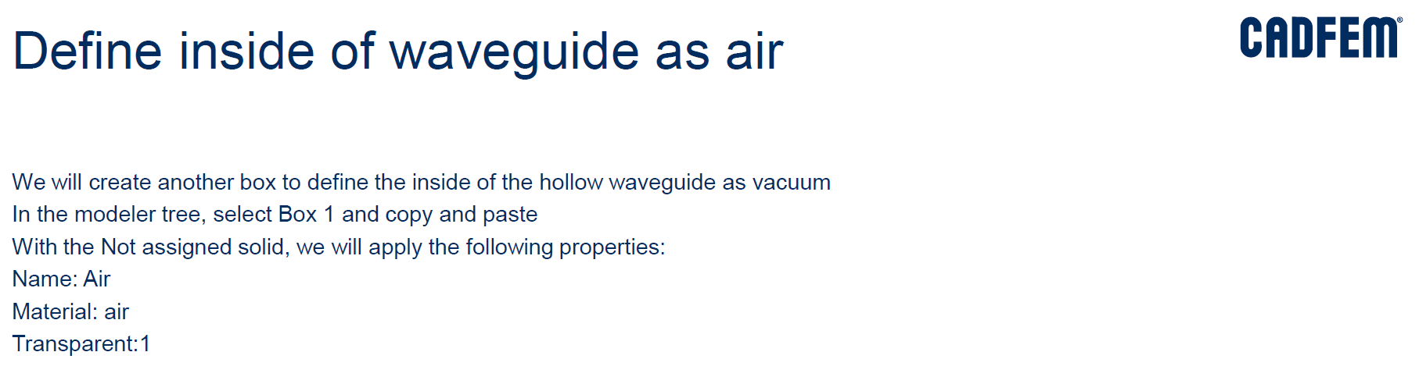

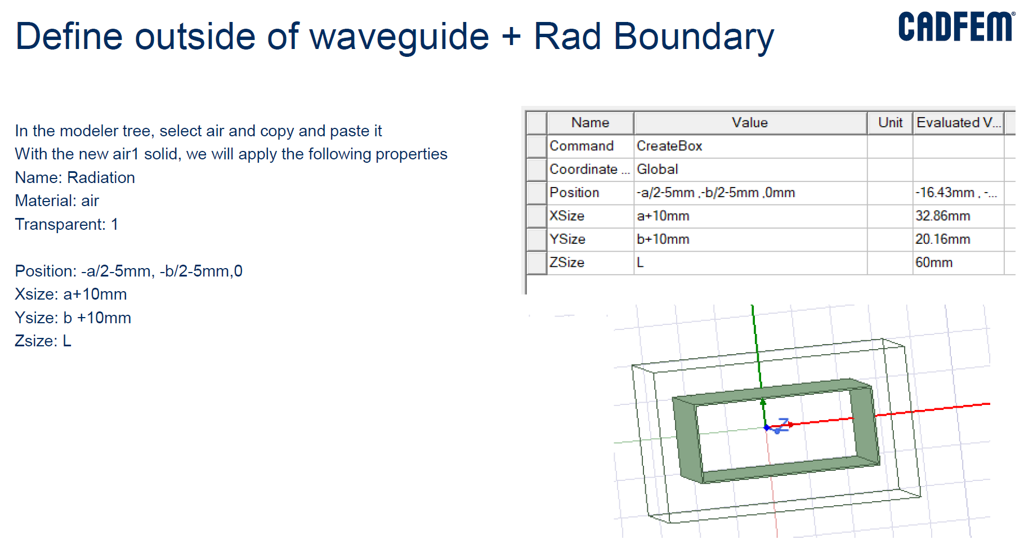

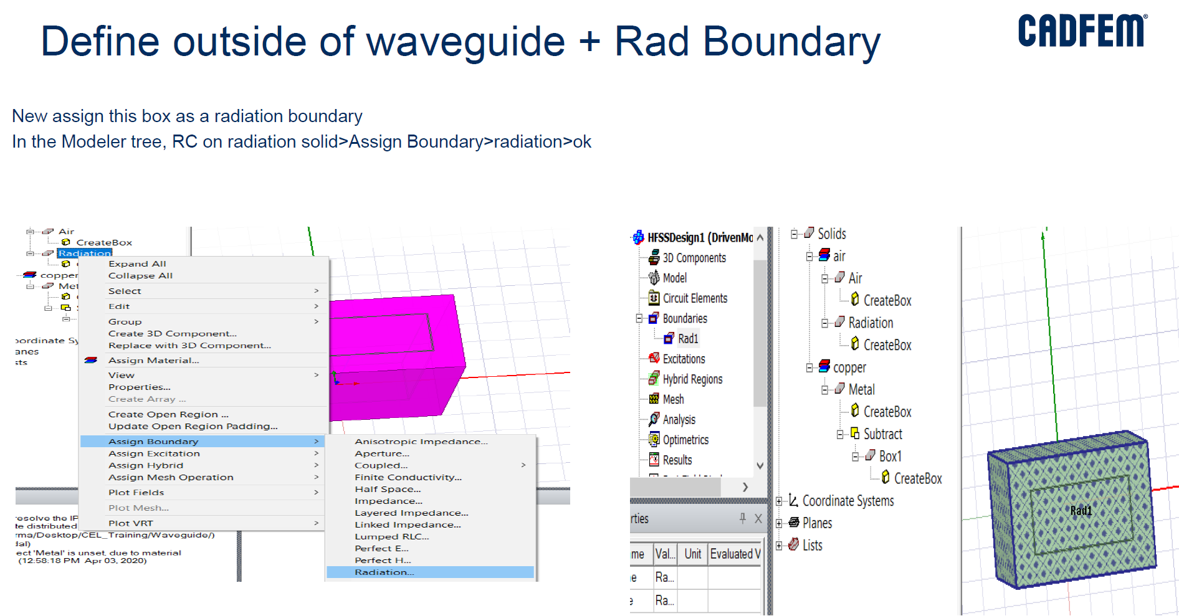

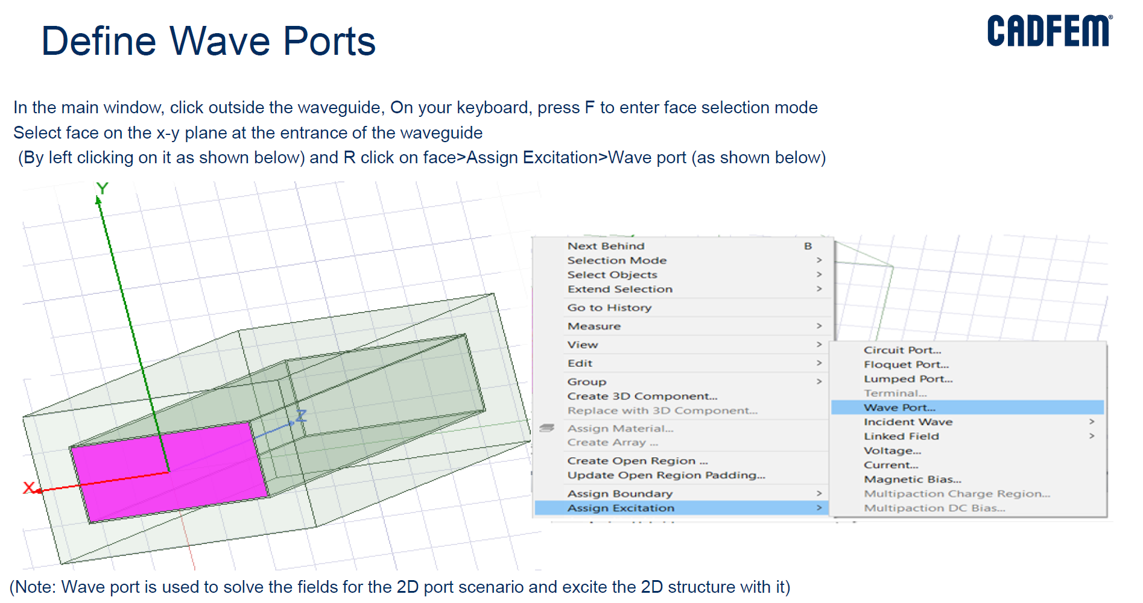

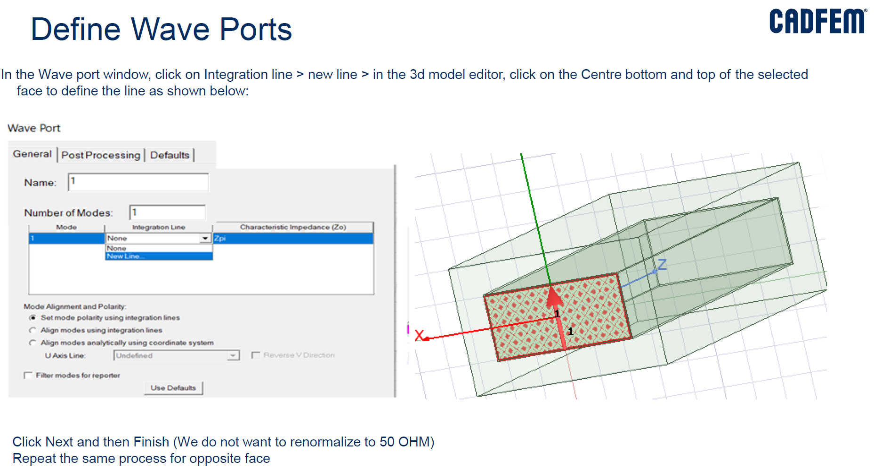

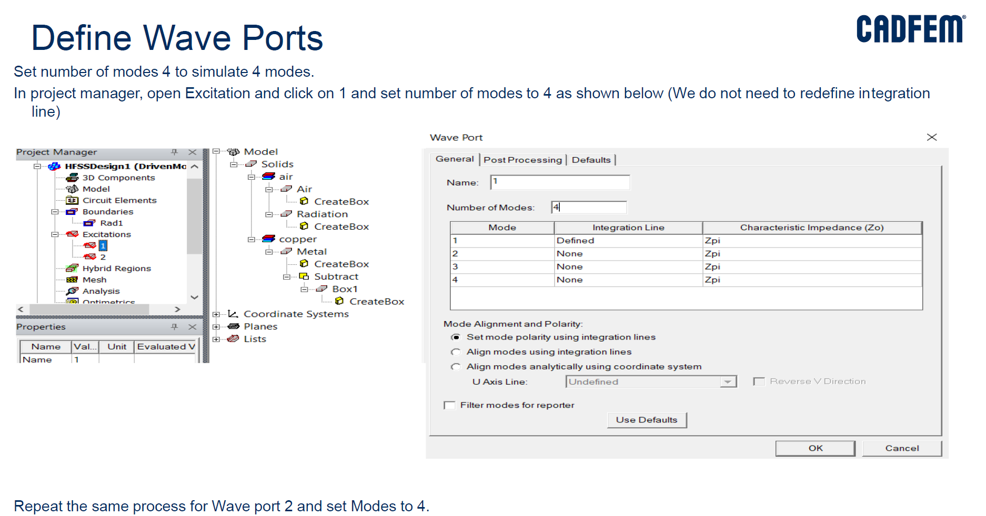

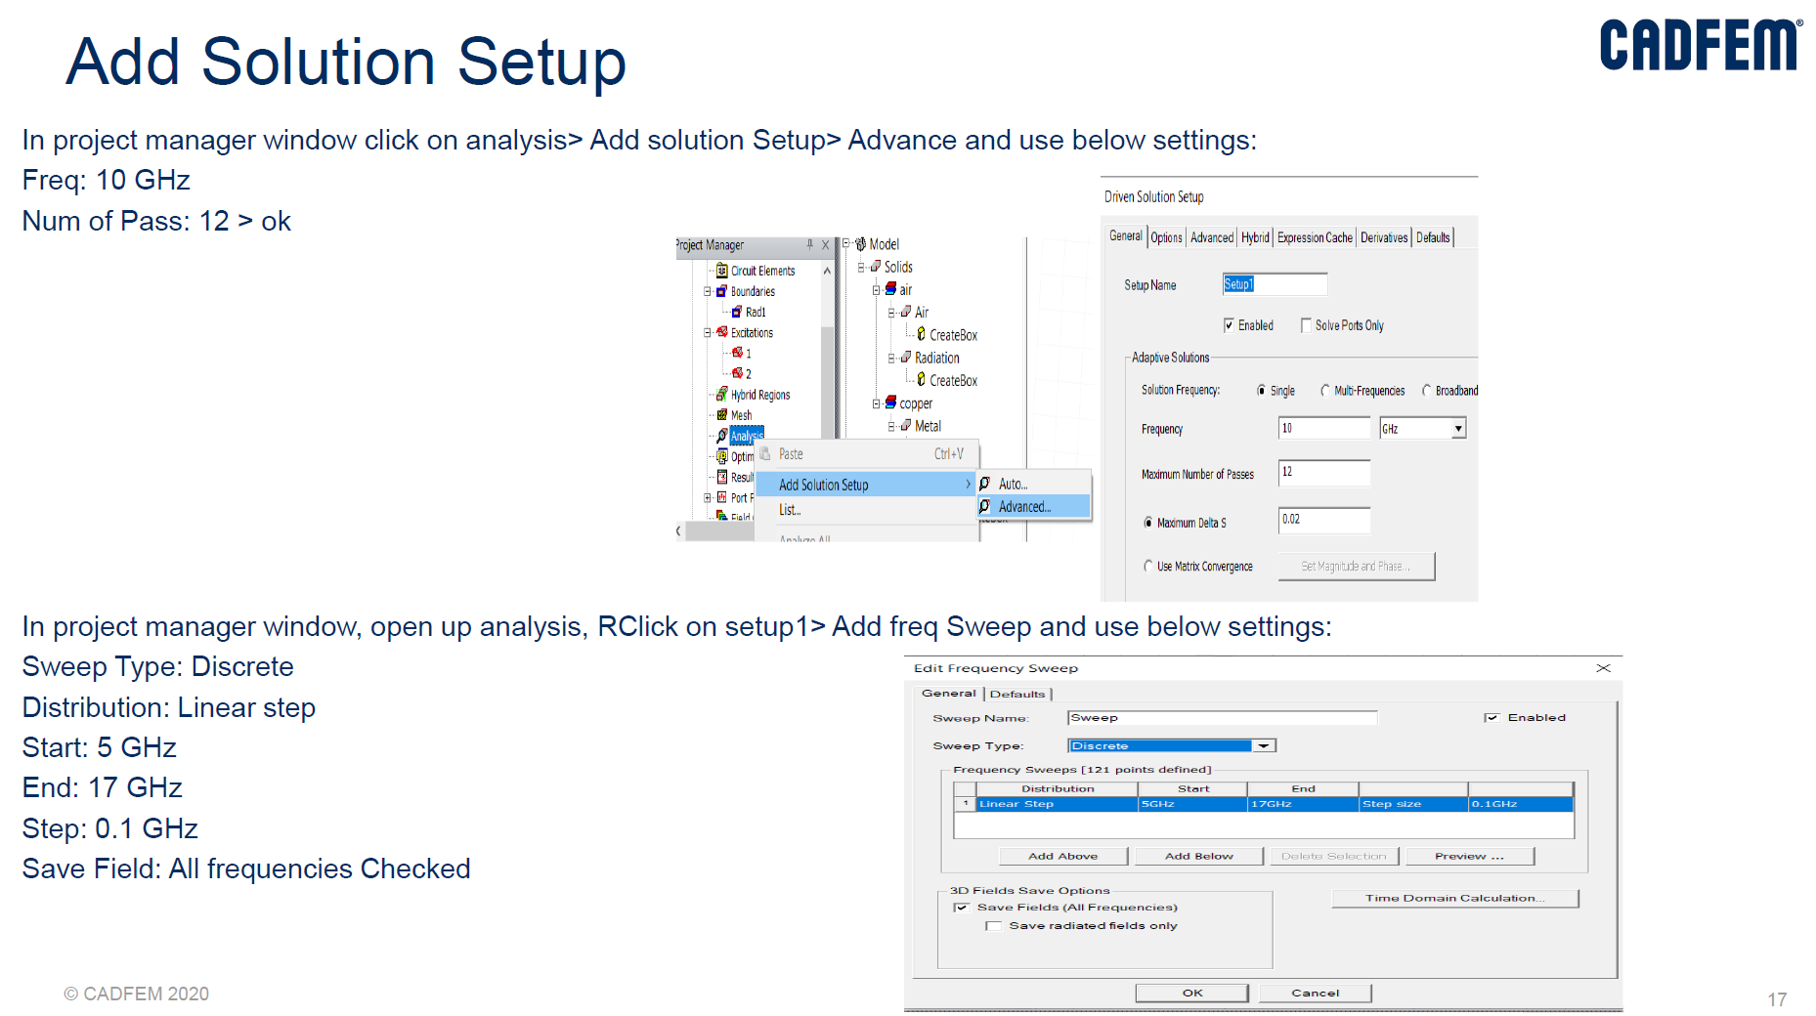

**Note: Continue the remaining steps in the lab manual for the results**

1. **Design and Simulation of Magic-Tee using HFSS**

**Magic Tee HFSS Procedure**

**Setting Tool Options**

•Note: In order to follow the steps outlined in this example, verify that the following tool options are set :

•Select the menu item Tools > Options > General Options…

•Expand the HFSS Branch

Left Mouse Click Boundary Assignment

•Use Wizards for data input when creating new boundaries:

* Checked

•Duplicate boundaries/mesh operations with geometry:

* Checked

•Expand the 3D Modeler Branch

Drawing: Edit properties of new primitives:

* Checked

Expand the Display Branch

Rendering Set Default Transparency to 0.7

History Tree: Select last command on object/submodel select:

* Checked

1. Draw the Box and its dimension

Draw🡪 Box🡪Use Mouse Pointer🡪 Select the Origin (0,0,0) as position and draw(Ref Fig below)

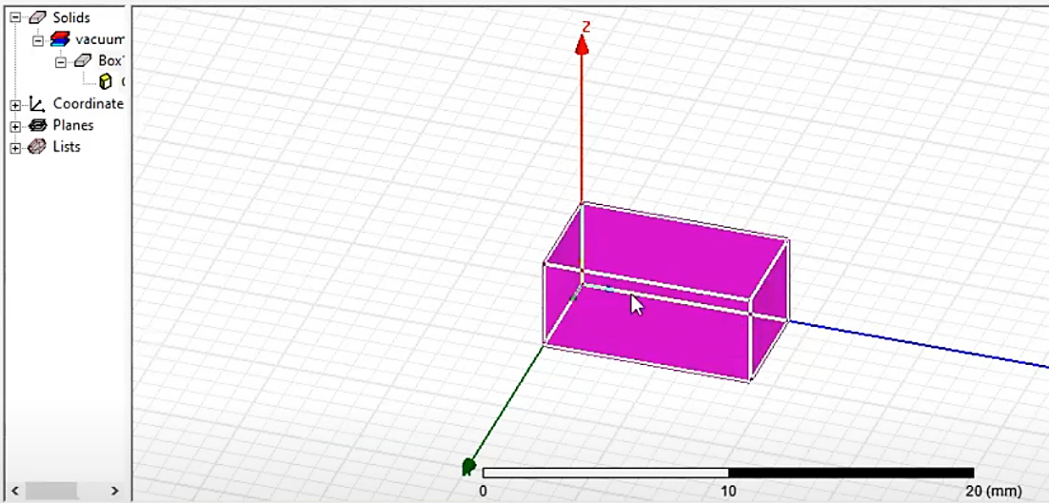

1. Changing the dimensions

Model🡪vacuum🡪 Box🡪CreateBox

Position🡪(-11.43, 0, -5.08) (Note: To keep the waveguide positioning at centre of XZ plane axis)

XSize🡪 22.86

YSize🡪100

ZSize🡪10.16

1. Fit View Ctrl +D or View🡪 Fit all & duplicate the box for all 4 arms

Select Box🡪 Edit🡪 Duplicate🡪 Around Axis (Ref Fig below)

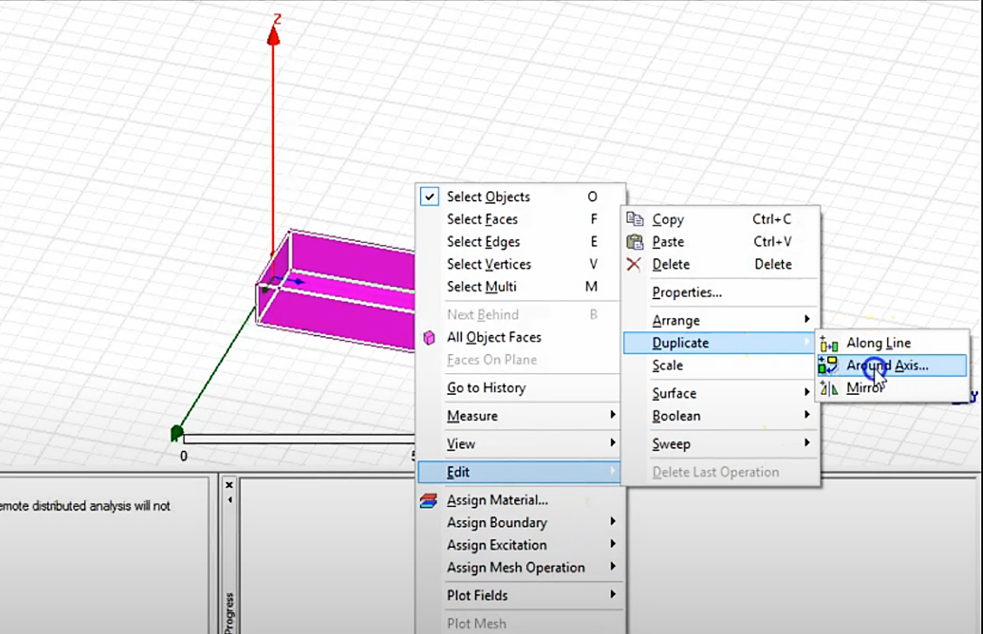

Coplanar-arm (Port 2)

Axis: Z

Angle: 90 deg

Total number: 2

Similarly, Coplanar-arm (Port 1)

Axis: Z

Angle: -90 deg

Total number: 2

For E-plane arm (Port 3) (Ref Fig below)

Select the coplanar port1 arm,

Axis: Y

Angle: -90 deg

Total number: 2

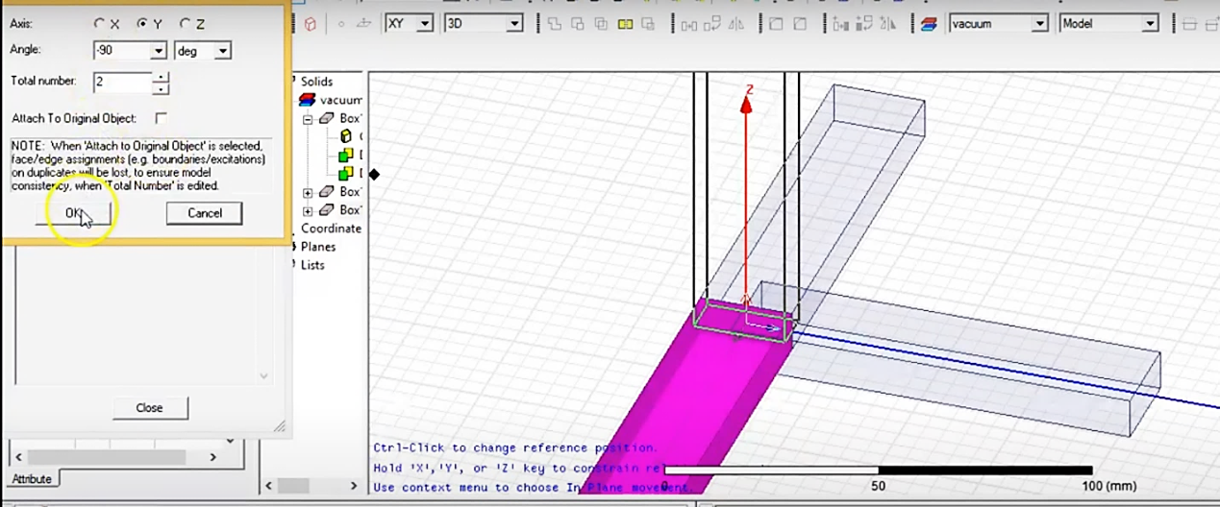

1. Unite all the Box

Edit🡪 Select All Visible or Ctrl + A

Modeler🡪 Boolean🡪Unite

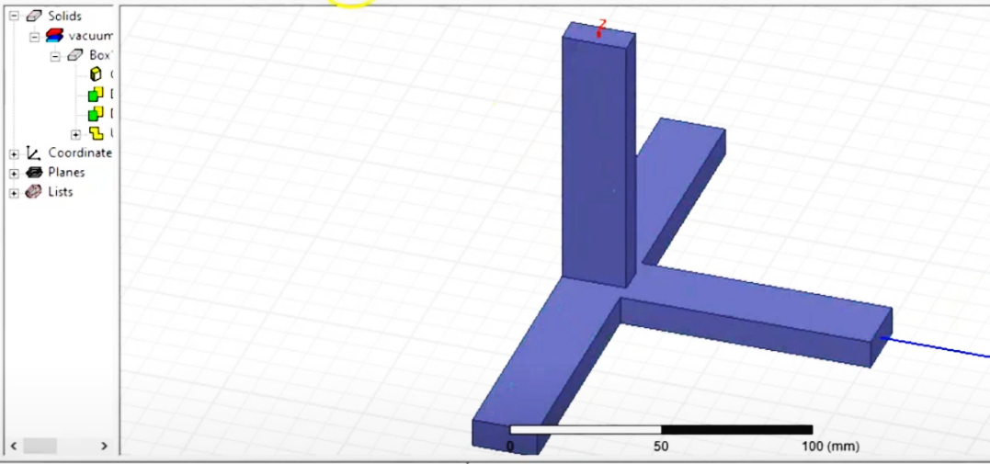

1. Assign Boundary and excitation to the port arms

Select Ctrl + Select all the arms except faces

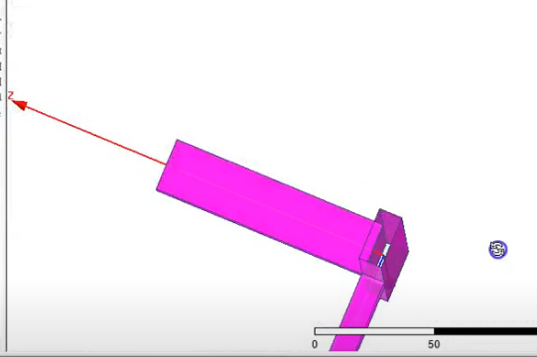

Right click on mouse🡪 Assign Boundary🡪 Perfect E🡪Name🡪PerfE1

1. Assign excitation to wave ports

Use mouse pointer click on face of port and Assign Excitation🡪Waveport🡪 Name🡪3, Integration line🡪 New Line🡪

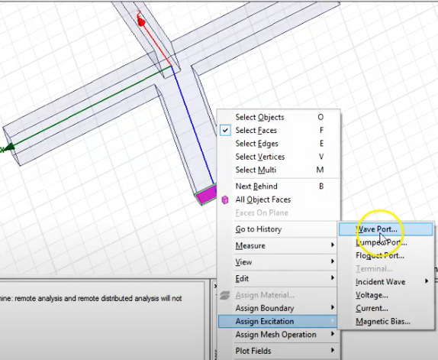

Select the integration line from bottom to top on the face as shown below

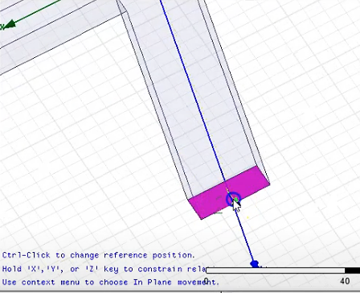 

Similarly do for all the arms port1, 2 & 4

**Note: Continue the remaining steps in the lab manual for the results**

**EXPERIMENT 8**

**Design and Simulation of Patch Antenna and Optimetrics using HFSS**

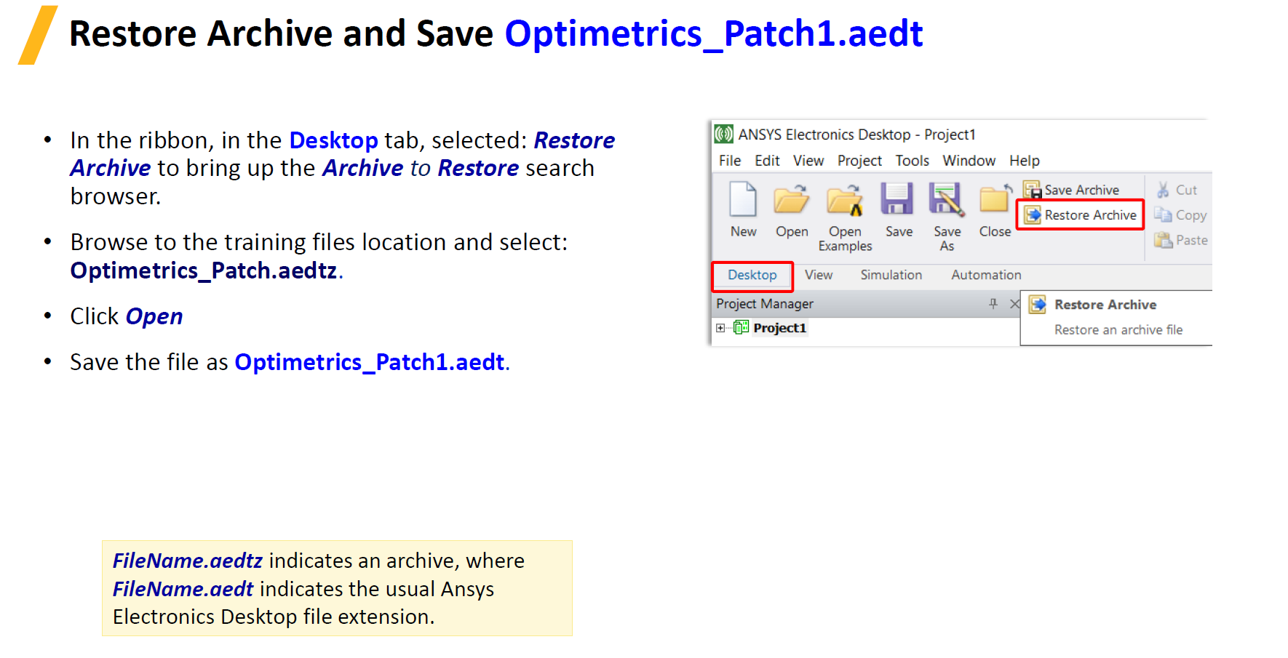

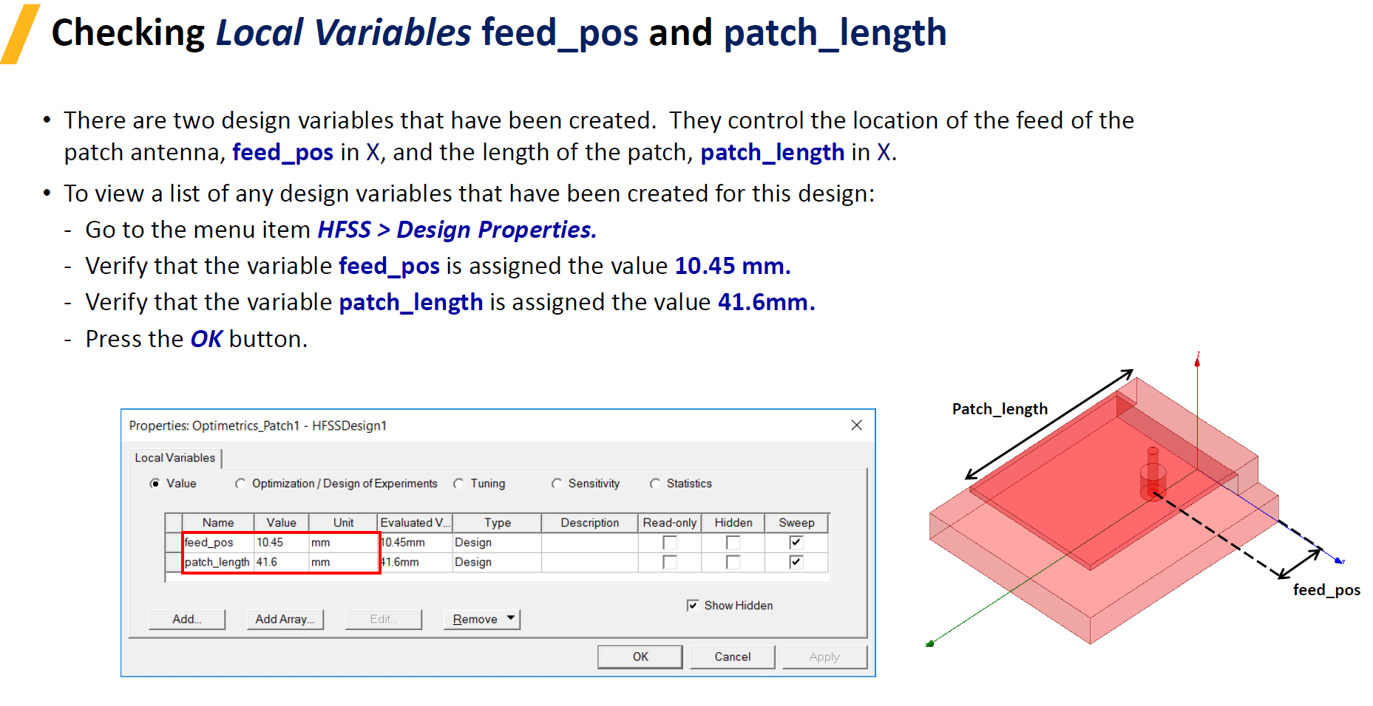

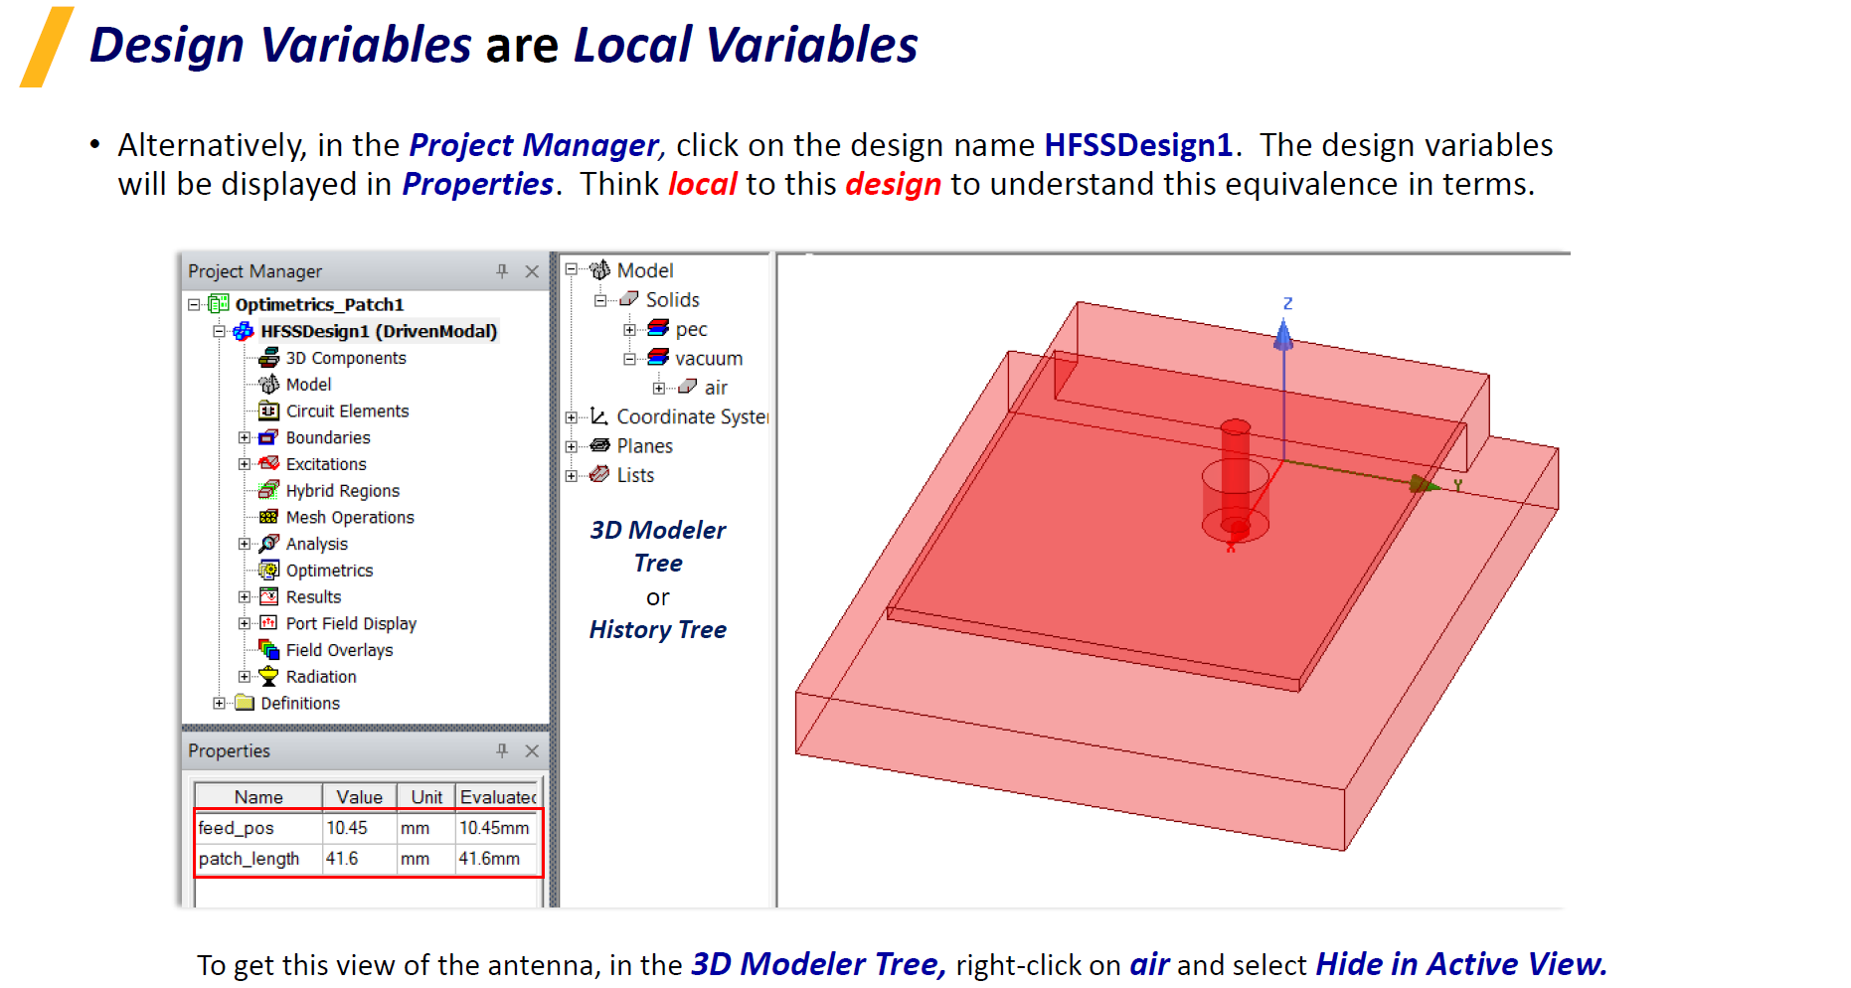

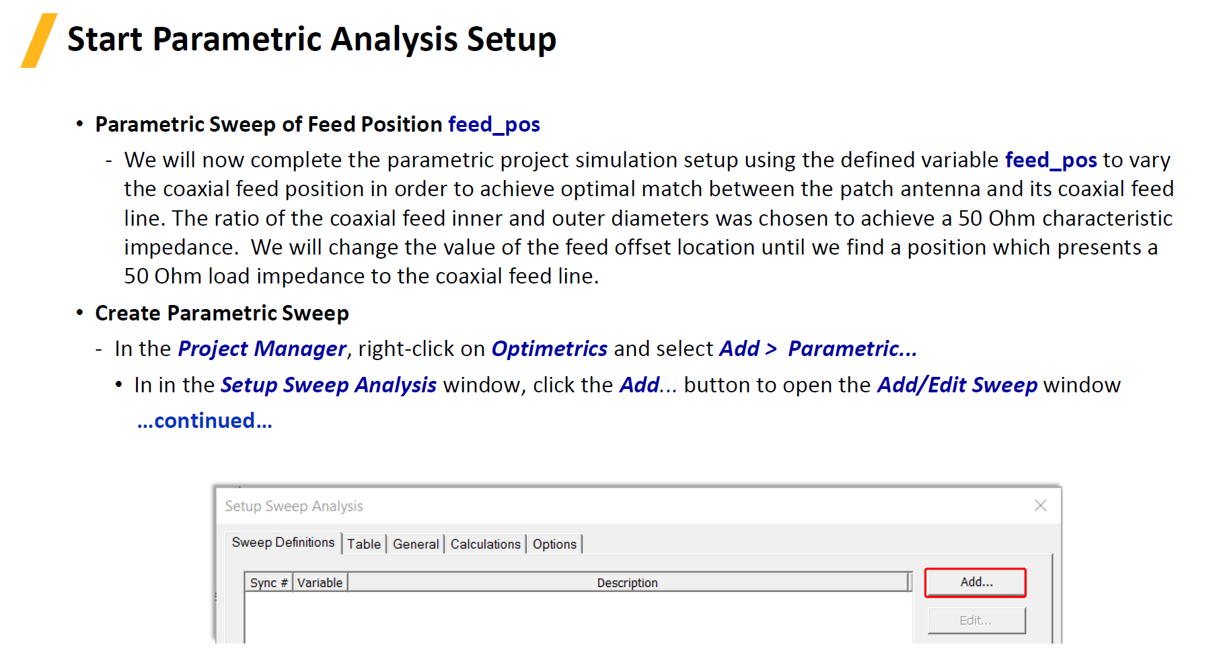

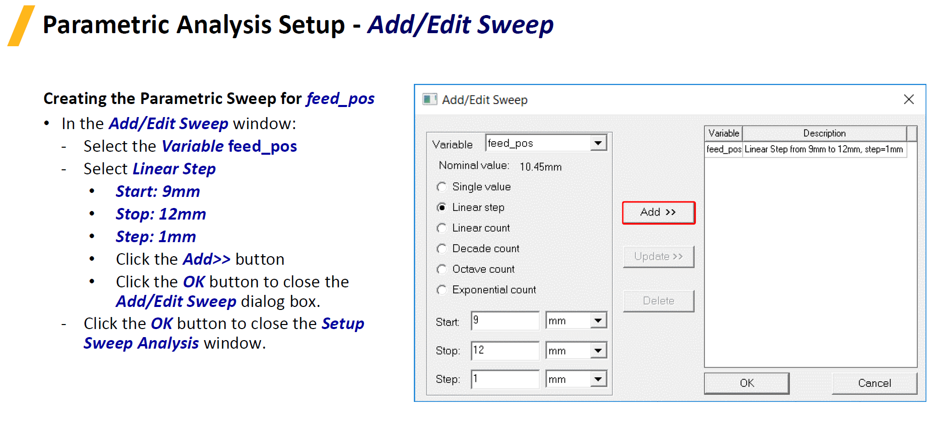

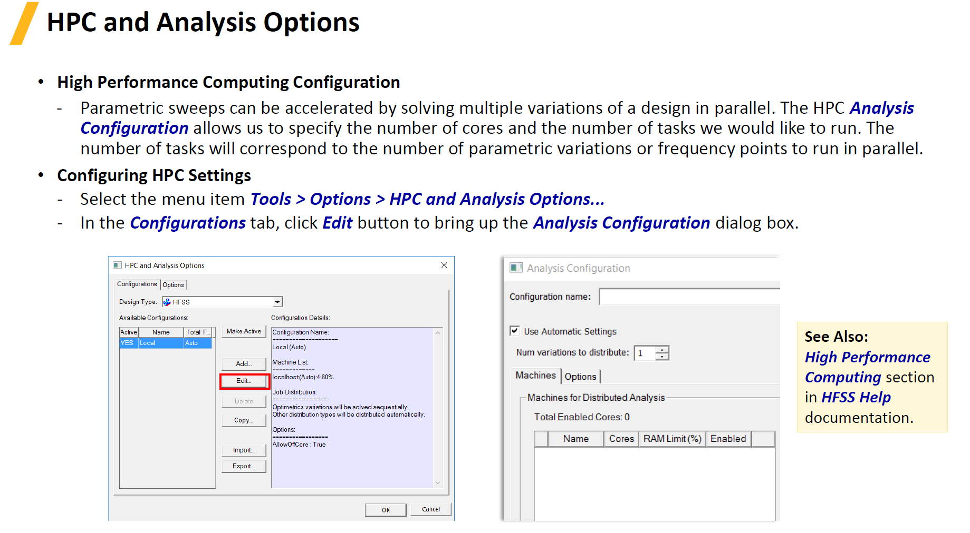

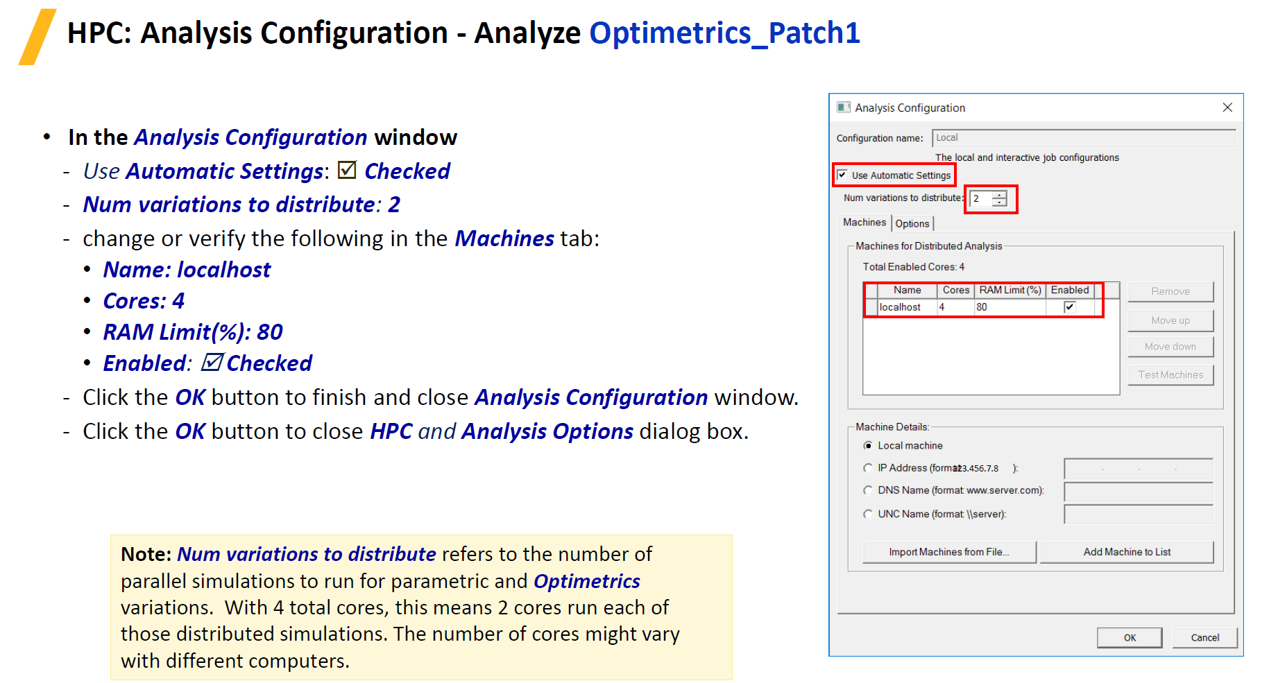

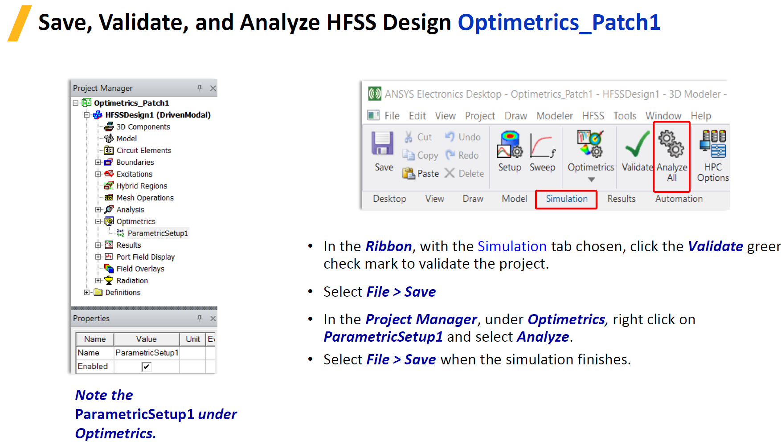



**Note: Continue the remaining steps in the lab manual for the results**